Joint Inspection Team (JIT) Report

Mission for Integrated Development of Horticulture

Tamil Nadu

(13.09.2015 to 19.09.2015)


Department of Agriculture, Cooperation & Farmers Welfare
Ministry of Agriculture & Farmers Welfare, Government of India

Joint Inspection Team (JIT) Report of Mission for Integrated Development of Horticulture for Tamil Nadu State

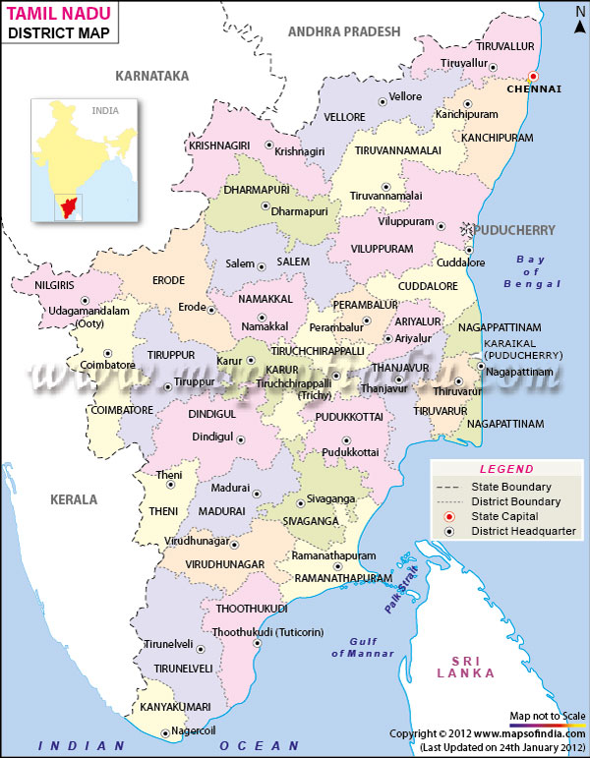

INDEX

Sl.No | Topic | Page No.
1. | General Observations/Recommendations of JIT | 3
2. | Introduction | 4-10
3. | Field Visits
(i) | Visit to District Perambalur | 11-19
(ii) | Visit to District Cuddalore | 20-33
(iii) | Visit to District Ariyalur | 34-44
(iv) | Visit to District Thanjavur | 45-54

Dates of Visit: From 13.09.2015 To 19.09.2015

Team Members:

- Dr. M. Tamil Selvan, Additional Commissioner (Hort.), DAC&FW, MOA&FW ,GOI, New Delhi

- Dr. H V L Bathla, Chief Consultant (MIDH), DAC&FW, MOA&FW,GOI, New Delhi.

- Dr. S V Kottiswaran, PI (PFDC), Agri. Engg. College Institute, TNAU, Coimbatore.

- Dr. J. Rajangam, Professor and Head, HC&RI Periyakulam,Theni

- Mr. Homey Cheriyan, Director, Director of Arecanut and Spices Development, Calicut, Kerala.

- Mr. Ravindra Kumar, Deputy Director, Directorate of Cashew and Cocoa Development, Cochin.

- Mr. R. Mahendrakumar, Assistant Director of Horticulture (NHM), TANHODA, Chennai (SHM Representative).

General Observations / Recommendations:

- In order to increase the production, the vegetables growers need to be motivated to introduce F1 hybrid.

- Regulated market need to be established for marketing of cashew produce.

- As moringa crop gives more profitability, the area under this crop can be increased.

- Rejuvenation of old and senile cashew and mango orchards need to be taken up on priority basis.

- There is need to introduce choice varieties i.e. Alphonso, Imampasand, Kalapada, Banganapalli, etc of Mango and Lucknow- 49, Banarasi and Red Flesh for Guava through HDP.

- Facilities for processing of raw cashew need to be increased.

- NHM assistance received in case of horticulture mechanization component need to be displayed on the machinery for which assistance obtained.

- It has been observed that due to mortality of plants there are gaps in the orchards. These need to be filled up on priority basis.

- Training in canopy management and pruning operations need be imparted to the beneficiaries.

- Structures and capacity of low cost onion storage need to be standardized.

- To meet the growing demand of Planting Material for vegetable crops, there is a need to increase the number of shadenets in the State.

- For optimum utilization of mulching materials the standard recommendations for seasonal, annual and perennial crops need to be followed.

- Wherever area expansion programme is implemented, the concept of formation of clusters need to be adhered.

- In places of area expansion under fruits and TC Banana, micro irrigation has to be emphasized.

- Protected cultivation needs to be taken up for Perambalur district for off season vegetables.

- Plastic crates for transportation and marketing of produces has to be used to reduce the cost of packaging materials.

- In water scarce areas farm ponds with plastic lining can be constructed to harvest water.

State-Tamil Nadu
Geography

Tamil Nadu covers an area of 130,058 km² (50,216 sq mi), and is the eleventh largest state in India. The bordering states are Kerala to the west, Karnataka to the North West and Andhra Pradesh to the north. To the east is the Bay of Bengal and the union territory of Puducherry. The southernmost tip of the Indian Peninsula is located in Tamil Nadu. At this point is the town of Kanyakumari which is the meeting point of the Arabian Sea, the Bay of Bengal, and the Indian Ocean. The south boundary of India is Kanyakumari, Tamil Nadu.

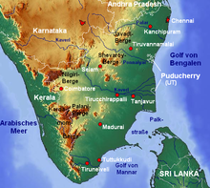

Topographic map of Tamil Nadu
Physical Feature:
The State is parted broadly into two natural divisions i.e., (a) the coastal plains and (b) the hilly western areas. It is further classified as Coromandal plains consisting of Kancheepuram, Tiruvallur, Cuddalore, Villupuram, Thiruvannamalai and Vellore and alluvial plains of Cauvery Delta expanding to Thanjavur, Nagapattinam Thiruvarur and part of Trichy and dry southern plains in Madurai, Ramanathapuram, Sivagangai, and Kanyakumari Districts. The Western Ghats averaging 3000’ to 8000’ of height run along the western part with the hill groups of Nilgiris and Anamalais on either side of it. Palani hills, Varashanad and Andipatti ranges are the major off-shoots of Ghats. The other prominent hills comprise of Javadhu, Shervarayan, Kalrayans and Pachai Malais. These ranges continue south of river Cauvery. A Plateau is found between these hills and the Western Ghats with an average elevation of 1000 feet raising west-ward. The highest peak Doddabettah in the Nilgris is 8650’ above M.S.L.

Western Ghats form a complete watershed and there is no river passes through them. The main streams i.e., Paraliyar, Vattasery Phazhayar etc., are of limited length and fall in the Arabian sea. All other rivers are east-flowing rivers. The main rivers of Tamil Nadu are Cauvery (with tributaries of Bhavani, Amaravathi, Noyyal) Vaigai, Tamaraparani, Palar, Ponniyar and Vellar. Tamil Nadu has a coastline of about 910 km (570 mi) which is the country’s third longest coastline.

Climate:

The climate of Tamil Nadu is basically tropical. Due to its proximity to the sea, the summer is less hot and winter is less cold in plains, the maximum daily temperature is 44.4’c and the minimum temperature is 4.4’c. Tamil Nadu is mostly dependent on monsoon rains, and thereby is prone to droughts when the monsoons fail. The climate of the state ranges from dry sub-humid to semi-arid. The state has three distinct periods of rainfall

- Advancing monsoon period, south west monsoon from June to September, with strong southwest winds;

- North east monsoon from October to December, with dominant north east winds;

- dry season from January to May.

The special feature of climatic conditions in Tamil Nadu is that the four seasons are not distinct and overlap with immediate next season. In the plains there is no winter season and in the hills summer is not severe allowing continuous production of horticultural crops in the state.

There are areas with temperate climate (above 2000 m), subtropical climate (1000 – 2000 m), humid tropical climate 500 – 1000m and tropical climate (upto 500 m) to accommodate all possible types of horticultural crops.

These overlapping seasons have made possible grapes to grow round the year, vegetables and spices in all possible crop rotations and systems of planting. Nearness to the equator and the presence of long stretch of Western Ghats, discontinuous Eastern Ghats and presence of hills and hillocks in the Plains help moderation of climate to ensure the required heat units and degree – days for growing different kinds of horticultural crops.

Broad classification of Horticultural Crops:

Horticulture crops are classified in to six categories viz., Fruit Crops, Vegetable Crops, Spices and Condiments, Plantation Crops, Flower Crops and Medicinal and Aromatic Plants.

Based on the climatic preferences they are classified as:

Tropical fruit crops like Banana, Mango, Citrus, Grapes, Guava, Sapota, Papaya, Ber, Pomegranate, Fig, Amla, Custard apple and Pineapple and Sub-Tropical fruits like, Mangosteen, Phalsa, Avocado, etc., The state is the largest producer of bananas, flowers, tapioca, the second largest producer of mango, natural rubber, coconut, groundnut and the third largest producer of coffee, sapota and Tea.

Fruit crops:

Fruits crops which come up in cool temperatures and high altitudes are known as temperate fruits. In the hilly areas of Tamil Nadu, the commonly grown temperate fruit crops are Apple, Pear, Persimmons etc., Mango and banana are the leading fruit crops in Tamil Nadu accounting for over 87 percent of the total fruit production.

Out of about 11.08 lakh ha. of Horticulture Crops in Tamil Nadu fruit crops account for 29.96%.

Vegetable Crops:

In Tamil Nadu, the major vegetable crops are Tapioca, Onion, Tomato, Brinjal, Potato, Lablab, Drumstick, etc., Out of about 11.08 lakh ha. of Horticulture Crops in Tamil Nadu, vegetables crops are cultivated in 2.84 lakh ha. accounting for 25.63%.

Spices & condiments

Spices and Condiments constitute a very important group of horticultural crops. High income generation and foreign exchange earnings are possible through exports of spices. Spices and Condiments are grown in 1.73 lakh ha. In Tamil Nadu which is around 15.61% of total horticulture crops. The important spices crops are Chilles (dried), Pepper, Turmeric, Tamarind, Cardamom, Cloves, etc.,

Plantation crops

Plantation crops are ideally taken up on hill slopes or in valleys. The important plantation crops grown in Tamil Nadu are Tea, Coffee, Rubber, Cashew, Bamboo, Cocoa, etc., About 2.75 lakh ha of plantation crops are grown which account for 24.82% of total horticulture crops.

Flowers

The major area under flowers constitutes domestic flowers such as Jasmine, Crossandra, Tuberose, Chrysanthemum, etc., more than twenty different varieties of flowers are cultivated and all flowers are grown according to the prevailing climatic condition. With its varying climatic conditions in the hill ranges and plains, Tamil Nadu offers rich scope for production of various flower crops. Flower crops are grown in 0.32 lakh ha. in Tamil Nadu out of 11.08 lakh ha of total horticulture crops.

Medicinal & Aromatic Plants

Medicinal & Aromatic plants are grown in about 0.12 lakh ha. There is a positive approach for increasing the area in the forth coming years due to potential export value of medicinal and aromatic plants. The important medicinal and aromatic Plants grown in Tamil Nadu are lemon grass, senna, coleus, glory lilly, periwinkle and other plan.

Area, Production & Productivity of Horticultural Crops
from 1980 – 81 to 2014 – 15
Sl.No. | Year | Area (Ha) | Prodn. (MT) | Prodty. (MT/Ha)
1. | 1980 – 81 | 461644 | 4477937 | 9.07
2. | 1981 – 82 | 548175 | 4084025 | 7.45
3. | 1982 – 83 | 568304 | 4321640 | 7.06
4. | 1983 – 84 | 563153 | 4631285 | 8.22
5. | 1984 - 85 | 595346 | 5470365 | 9.19
6. | 1985 – 86 | 597261 | 5311432 | 8.89
7. | 1986 - 87 | 583652 | 5384020 | 9.22
8. | 1987 – 88 | 614713 | 5859205 | 9.53
9. | 1988 – 89 | 598989 | 6302870 | 10.52
10. | 1989 – 90 | 615230 | 7299993 | 11.87
11. | 1990 – 91 | 603873 | 7087220 | 11.74
12. | 1991 - 92 | 628789 | 7936149 | 12.62
13. | 1992 - 93 | 676858 | 7395789 | 10.93
14. | 1993 – 94 | 718428 | 9061152 | 12.61
15. | 1994 – 95 | 717219 | 10142494 | 14.14
16. | 1995 – 96 | 688478 | 9727361 | 14.13
17. | 1996 - 97 | 722931 | 8779207 | 12.14
18. | 1997 - 98 | 764127 | 11128371 | 14.56
19. | 1998 - 99 | 786442 | 9837041 | 12.51
20. | 1999 – 2000 | 834545 | 9927608 | 11.89
21. | 2000 – 01 | 850222 | 11529792 | 13.56
22. | 2001 – 02 | 852645 | 11715345 | 13.74
23. | 2002 – 03 | 777172 | 9168424 | 11.79
24. | 2003 – 04 | 824586 | 9945502 | 12.06
25. | 2004 – 05 | 858552 | 12617300 | 14.70
26. | 2005 – 06 | 890189 | 14126277 | 15.89
27. | 2006 – 07 | 922017 | 16093071 | 17.45
28. | 2007 – 08 | 930902 | 16203786 | 17.41
29. | 2008 - 09 | 985591 | 16145197 | 17.4
30. | 2009 – 10 | 922005 | 14309053 | 15.52
31. | 2010 – 11 | 940395 | 14838629 | 15.78
32. | 2011 - 12 | 1001380 | 15261744 | 15.24
33. | 2012-13 | 943768 | 13607033 | 14.42
34. | 2013-14 (P) | 1094000 | 17164000 | 15.68
35. | 2014-15 (E)

Requirement and availability of Planting material in Tamil Nadu State during 2015-16

S.No. | Crop | Requirement for NHM 2015 -16  (No’s in lakhs) | Availability  (No’s in lakhs)
1 | Mango Grafts | 4.996 | 6.518
2 | Guava Layers | 2.816 | 2.377
3 | Papaya Seedlings | 11.250 | 11.250
4 | Pepper Cuttings | 8.325 | 10.000
5 | Clove Seedlings | 0.102 | 0.120
6 | Cashew Grafts | 2.920 | 3.348
7 | Loose Flowers Seedlings | 17.000 | 17.000
8 | Vegetable Seedlings | 159.642 | 162.000
9 | Spices Seedlings | 93.325 | 100.000

ACCREDITATION POSITION OF STATE HORTICULTURE FARMS IN TAMIL NADU STATE
S.No | Name of the Farm | Accreditation position | Star | Remarks
I | Coimbatore
1 | Anaikatty |  |  | To be applied after revival of farm activities.
2 | Kannampalyam
II | Cuddalore
3 | Vridhachalam | Accreditated | 2 star
4 | Neyveli | Accreditated | 2 star
III | Kodaikanal
5 | SHF Kodaikanal | Accreditated | No star | Recommended for improvement
6 | Bryant Park |  |  | Parks and Gardens
7 | Thandikudi | Accreditated | No star | Recommended for improvement
IV | Dindigul
8 | Reddiarchatram |  |  | Indo isreal project-COE for Vegetables
9 | Sirumalai
10 | Sandhaiyur |  |  | New farm - preliminary stage.
V | Kancheepuram
11 | Attur | Accreditated | 1 star | Recommended for improvement
12 | Vichanthangal | Accreditated | 1 star | Recommended for improvement
13 | Melkadirpur | Accreditated | No star | Recommended for improvement
14 | Melottivakkam | Accreditated | No star | Recommended for improvement
15 | Pitchivakkam |  |  | Not applicable
VI | Kanyakumari
16 | Kanniyakumari | Accreditated | 2 star
17 | Pechiparai | Accreditated | 2 star
VII | Krishnagiri
18 | Thimmapuram | Accreditated | 2 star
19 | Jeenur | Accreditated | 1 star
VIII | Trichy
20 | Thorakudi |  |  | Application will be sent during 2016-17
21 | Mudalaipatti | Accreditated | 2 star
IX | Namakkal
22 | Semmedu | Accreditated | 2 star
23 | Padasolai | Accreditated | 1 star
X | Pudukottai
24 | Kudumianmalai | Accreditated | 2 star
25 | Vallathirakottai | Accreditated | 2 star
26 | Nattumangalam | Accreditated | 2 star
XI | Salem
27 | Yercaud | Accreditated | 2 star
28 | G.O Karumandurai | Accreditated | 3 Star
29 | Maniyarkundram | Accreditated | 2 star
30 | SHF Karumandurai | Accreditated | 2 star
32 | Mulluvadi | Accreditated | No star | Recommended for improvement
33 | Sirumalai | Accreditated | 2 star
34 | GBG, Yercaud |  |  | Parks and Gardens
35 | GHG. Yercaud |  |  | Parks and Gardens
XII | Sivagangai
36 | Devakottai | Accreditated | 2 star
37 | Nemam | Accreditated | 3 Star
XIII | Thanjavur
38 | Marungulam | Accreditated | 2 star
39 | Aduthurai | Accreditated | 1 star
XIV | Theni
40 | Periyakulam | Accreditated | 2 star
XV | Chennai
41 | Madhavaram |  |  | Only ornamentals, Not applicable
42 | Semmozhi poonga |  |  | Parks and Gardens
XV | Tirunelveli
43 | Courtalam |  |  | Parks and Gardens
XVI | Vellore
44 | Thagarakuppam |  |  | No production activity
45 | Kudappattu | Accreditated | 1 star
46 | Navlok | Accreditated | 2 star
XVII | Virudhunagar
47 | Poovani | Accreditated | 2 star
48 | Srivilliputhur | Accreditated | 1 star
XVIII | Nilgiris
49 | Burilar | Application is in process by NHB
50 | Kallar | Application is in process by NHB
51 | Katteri | Application is in process by NHB
52 | Devala | Application is in process by NHB
53 | Doddabetta | Application is in process by NHB
54 | P.S.Coonoor | Application is in process by NHB
55 | Sims Park Coonoor |  |  | Parks and Gardens
56 | Government Rose Garden | Application is in process by NHB |  | Parks and Gardens
57 | Government Botanical garden |  |  | Parks and Gardens
58 | Nanjanad |  |  | Only seed production, Not applicable
59 | Thummanatty |  |  | Not applicable
60 | FPU, Coonoor |  |  | Fruit products only, Not applicable
61 | Colgraine |  |  | Only seed production, Not applicable
XIX | Madurai
62 | Poonjuthi |  |  | Report awaited from NHB
XX | Dhamapuri
63 | Polyampalli |  |  | Application will be sent to NHB during 2015-16
64 | Vathalmalai |  |  | Parks and Gardens
XXI | Ramanathapuram
65 | Oriyur |  |  | Application will be sent to NHB during 2017-18.
XXII | Tiruvannamalai
66 | Jawadhu Hills |  |  | Application will be sent to NHB during 2017-18.

 | ABSTRACT
 | Total number of Farms/Parks & Gardens | 66
 | Total farms Accreditated | 33
 | Not applicable | 20
 | New Farms | 5
 | Application in process by NHB | 7
 | Report from NHB awaited | 1

 | Star
 | Single star |  | 7
 | Two star |  | 19
 | Three star |  | 2
 | No star |  | 5
 | Total |  | 28

DISTRICT: PERAMBALUR

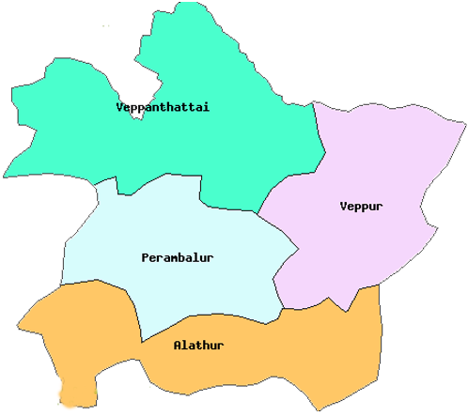

LOCATION
Perambalur is an administrative district in the State of Tamil Nadu in India. The district headquarters are located at Perambalur. The district occupies an area of 1,752 km² and has a population of 5,54,511 (as of 2011), making it the least populous in the state.
Perambalur district is a centrally located inland district of Tamil Nadu, spread over 3,69,007 ha, which was trifurcated from the erstwhile composite Tiruchirappalli district and was formed on 1 November 1995. The district is bounded by Cuddalore district in the north, Tiruchirappalli district in the south, Ariyalur in the east and Salem and Tiruchirappalli districts in the west. The total geographical area of the district is 1,75,735 ha, and net sown area and gross sown area are 1,03409 ha and 1,11,861 ha, respectively. The net area under irrigation is 29,268 ha.
Geo Code
North Latitude : 11. 14' 6"
East Longitude : 78.52'59"
Agro Climatic Zone
Sub Zone -I North Eastern Zone
Sub Zone -II North western Zone
NINE FOLD LAND USE PATTERN
S.no | Land Classification | Area in ha
1 | Forest | 9242.385
2 | Permanent and Unculturable waste | 2786.46
3 | Land put to non Agricultural uses | 28538
4 | Culturable wastes | 4670.725
5 | Permanent pasture | 152.365
6 | Land under trees not included under net area sown. | 1296.55
7 | Current fallows | 6909.74
8 | Other fallows | 11690.02
9 | Net Area Sown | 103409.34
* | Reserve Forest | 7039.46
* | Total Geographical Area. | 175735
* | Area sown more than once | 8452
* | Gross Sown Area | 111861.34

SOIL TYPE AND BLOCK LEVEL FERTILITY INDEX
S.  No | Block Name | Soil EC |  | Soil pH | Soil Tex  ture |  | N | P |  | K
 |  |  |  |  |  |  |  | Bray | Olsen | K
1 | Perambalur | 0.5-1.9 |  | 7.2-8.7 | CL to SCL |  | 55 to 136 | 10 to15 | 4to9 | 135to 389
2 | Alathur | 0.3-1.8 |  | 8.0-9.4 | CL to SCL |  | 116 to  258 | 19 to 35 | 4to18 | 161to358
3 | Veppur | 0.5-1.7 |  | 8.0-8.4 | CL to SCL |  | 115 to 287 | 12 to42 | 6to18 | 125to347
4 | Veppanthattai | 1.0-1.2 |  | 7.7-8.0 | CL to SCL |  | 86 to 315 | 15 to 55 | 7to24 | 115to445
 |  | Abbreviations
 |  | CL | Clay Loam
 |  | SCL | Sandy clay loam

CROPPING PATTERN
S. No | Cropping Pattern | Month
1 | Turmeric+onion-/Paddy | April-July / August-January
2 | Green-manure-Paddy/Chillies | July-August / September-January
3 | Paddy-Gingelly/Onion | September-January / March-June
4 | Tapioca./onion | September-January / March-June
5 | Maize/chillies | September - February
6 | Onion-Vegetables | September-January / March-June
7 | Onion | July - Aug to Oct-Nov
8 | vegetables | August - Feburary
9 | Sugarcane/Brinjal/Gourds | Dec -Jan to March- April
10 | Onion-Ground nut | Jan-Feb to Apil -May
11 | Brinjal-Gingelly | April-May / June - july

DETAILS OF BLOCK, TALUK, FIRKA AND REVENUE VILLAGES

S.No | Name of the Taluk | Block | No of Revenue Village | Name of the Firkka
1 | Perambalur | Perambalur | 27 | Perambalur, Kurumbalur
2 | Veppanthattai | Veppanthattai | 39 | Vengalam, Valikandapuram, Pasumbalur
3 | Alathur | Alathur | 39 | Chettikulam, Kolakanatham, Koothur
4 | Kunnam | Veppur | 47 | Varagoor, Vadakkalur, Keelapuliyur

RAINFALL PATTERN IN PERAMBALUR DISTRICT (In mm)

Sl.  No | Month | Normal  Rainfall REVENUE | Normal  Rainfall | Cumulative rainfall | 2013 |  | 2014 |  |  | 2015
 |  |  |  |  | Rain fall Received | Rainy Days | Rain  fall Received | cumulative rainfall | Rainy Days | Rainfall Received | cumulative rain fall | Rainy Days
1 | Jan | 16.00 | 16.00 | 16 | 0.60 | 0 | 0.00 | 0.00 | 0 | 38.8 | 38.80 | 1
1 | Feb. | 12.00 | 10.00 | 26 | 12.8 | 2.0 | 0.00 | 0.00 | 0.0 | 3.60 | 42.40 | 1
winter |  | 28.00 | 26.00 |  | 13.4 | 2.0 | 0.00 |  | 0.0 | 42.4 |  | 2
2 | March | 12.00 | 12.00 | 38 | 11.2 | 1.0 | 0.00 | 0.00 | 0.0 | 0 | 42.40 | 0
2 | April | 24.00 | 30.00 | 68 | 13.0 | 2.0 | 0.00 | 0.00 | 0.0 | 141 | 183.9 | 8
2 | May | 55.00 | 57.00 | 125 | 39.4 | 4.0 | 192 | 192.6 | 9.0 | 81. | 264.9 | 6
summer |  | 91.00 | 99.00 |  | 63.7 | 7.0 | 192 |  | 9.0 | 222 |  | 14
3 | June | 42.00 | 32.00 | 157 | 30.8 | 1.0 | 24.0 | 216.6 | 2.0 | 33.6 | 298.6 | 6
3 | July | 48.00 | 38.00 | 195 | 5.80 | 3.0 | 44.6 | 261.2 | 3.0 | 29.1 | 327.8 | 2
3 | Aug. | 95.00 | 75.00 | 270 | 203 | 1.0 | 155 | 417.0 | 12.0 | 107 | 435.4 | 6
3 | Sep. | 129.0 | 125.0 | 395 | 172 | 13 | 56 | 473.3 | 5.0 |  | 624.32
sw.monsoon |  | 314.0 | 270.0 |  | 412 | 18 | 280 |  | 22 | 170 |  | 14
4 | Oct | 172.0 | 173.0 | 568 | 136 | 9.0 | 239 | 713 | 17 |  | 435.4
4 | Nov | 223 | 223 | 791 | 144 | 13 | 92 | 805 | 8.0 |  | 435.4
4 | December | 80.00 | 70.00 | 861 | 44.4 | 6.0 | 66.76 | 872.56 | 8.0 |  | 435.
Nw.monsoon |  | 475 | 466 |  | 325 | 4.0 | 399 |  | 33 |  |  | 0
 | Total | 908 | 861 |  | 814 | 31 | 872 |  | 64 | 435 |  | 30

IRRIGATION SOURCES
Sl. No | Sources/Block wise | No | Gross Area irrigated (Ha) | Net Area irrigated (Ha) | Irrigation Intensity
1 | Tanks | 265 | 10472 | 8523.42 | 122.86
2 | Wells
 | 1) Open wells | 26908 | 24622 | 20630 | 119.35
 | 2) Bore wells | 1140 | 80.525 | 60.49 | 133.12
 | 3) Tube wells | 184 | 85 | 53.2 | 159.77
Total |  | 28497 | 35259.525 | 29267.11

AREA & PRODUCTION OF HORTICULTURE CROPS
(2009-2010 to-2013-2014)
S.  No | Name of the Crop | 2009-10 |  | 2010-11 |  | 2011-12 |  | 2012-13 |  | 2013-2014
S.  No | Name of the Crop | Area (Ha) | Prodn. (MT) | Area (Ha) | Prodn. (MT) | Area (Ha) | Prodn. (MT) | Area (Ha) | Prodn. (MT) | Area (Ha) | Prodn. (MT)
1 | Mango | 167 | 1094 | 209 | 1379 | 182.44 | 1188 | 198 | 1289 | 182 | 1189
2 | Banana | 184 | 9826 | 245 | 13095 | 234.3 | 12613 | 210 | 11305 | 234 | 12612
3 | Guava | 19 | 446 | 21 | 491 | 20.415 | 225 | 32 | 353 | 20 | 225
4 | Tapioca | 1743 | 73410 | 1766 | 72030 | 1297.38 | 54334 | 1373 | 57501 | 1297 | 54334
5 | Onion | 7795 | 62362 | 9278 | 67728 | 6513.26 | 61876 | 5621 | 53400 | 6513 | 61876
6 | Brinjal | 23 | 269.0 | 27 | 275 | 94.76 | 2029 | 46 | 985 | 95 | 2029
7 | Tomato | 70 | 908.0 | 23 | 1075 | 80.355 | 2001 | 67 | 1669 | 80 | 2001
8 | Chillies | 274 | 480.00 | 412 | 626 | 300.525 | 537 | 191 | 341 | 301 | 536
9 | Coriander | 114 | 40 | 56 | 20 | 18.26 | 6 | 16 | 5 | 18 | 6
10 | Turmeric | 1247 | 6983 | 1740 | 9570 | 1313.61 | 7502 | 958 | 5471 | 1314 | 7502
11 | Tamarind | 133 | 306 | 133 | 299 | 134.71 | 333 | 124 | 306 | 135 | 333
12 | Jasmine | 3 | 23 | 9 | 68 | 12.195 | 95 | 14 | 109 | 12 | 95
13 | Marigold | 43 | 241 | 27 | 151 | 40.27 | 242 | 21 | 126 | 20 | 122

PLACES OF HORTICULTURE IMPORTANCE IN THE DISTRICT
Sno | Name of the village | Horticulture crops
1 | Elanthalapatty | Onion, Flowers
2 | Irur | Onion
3 | Ammapalayam | Onion, Tuberose
4 | Malayalapatty | Tapioca,
5 | Kadambur | Coleus
6 | Annamangalam | Tuberose,
7 | Veppanthattai | Tapioca, Turmeric
8 | Keelapuliyur | Turmeric, Tapioca
9 | Sillakudi | Vegetables (Tomato, Brinjal)
10 | Kurumbalur | Vegetables

FIELD VISIT
Beneficiary No-1
Area Expansion / Rejuvenation

S.No. | Details | Remarks
1 | Name & address of Beneficiary whose field visited. | J. Jayaraman S/o Jeganathan, Nochiyam , Perambalur Block, Perambalur District.
2 | Total land available with the beneficiary (ha). | 2.00 Ha.
3 | Crop Cluster under which covered. | 0.32Ha.
4 | Name & variety of crop planted. | T .C. Banana
5 | Source of planting material. | Tissue culture plants
6 | Number of planting material. | 1000 nos.
7 | Number of plants planted/ rejuvenated. | 1000 nos.
8 | Date of plants which survived (also indicate percentage survival). | 18/04/2015 & survival -95 %
9 | Total amount of subsidy assistance due to the beneficiary as (Rs.) | Rs.9,964/-
10 | Amount paid and date of payment. | Rs.9,964 & 30.04.2015
11 | Mode of payment. | Though ECS
12 | Source of Irrigation Water (Bore well/ Tube well/ Canel) | Open well
13. | Whether Drip/ Sprinkler System in use. | Drip system installed
14. | Other inputs provided. | -
15. | Whether assistance available for Organic Farming | -
16 | If so, area covered | -
17. | Assistance available | -
18. | Available marketing facility for the crop. | Local market,
19. | Other infrastructure available in the vicinity.
20. | General upkeep of the plot;  Very good/ Good / Average/ Poor.
21. | Any other relevant observation by the JIT.

Observations:

- The TC Banana Plants establishment is good.
- The team appreciated the efforts made by the farmer pertaining to nutrient management.

- Some incidence of potash deficiency was observed.

Beneficiary No-2

Area Expansion / Rejuvenation

Sr. No. | Details | Remarks
1 | Name & address of Beneficiary whose field visited. | S. Krishnaraj  S/o Srinivasan, Poolambadi, Veppanthattai Block, Perambalur.
2 | Total land available with the beneficiary (ha). | 3.25 Ha
3 | Crop Cluster under which covered. | 2.75 Ha
4 | Name & variety of crop planted. | Guava- L-49
5 | Source of planting material. | Guava Layers from State Horticulture Farm
6 | Number of planting material. | 3055 Nos.
7 | Number of plants planted/ rejuvenated. | 3055 Nos.
8 | Date of plants which survived (also indicate percentage survival). | 25.07.2014, survival 90%
9 | Total amount of subsidy assistance due to the beneficiary as (Rs.) | Rs.48,372/-
10 | Amount paid and date of payment. | Rs.48,372/- , 17.11.2014
11 | Mode of payment. | Through ECS
12 | Source of Irrigation Water (Bore well/ Tube well/ Canel) | Open well
13. | Whether Drip/ Sprinkle System in use. | Drip System installed
14. | Other inputs provided. | -
15. | Whether assistance available for Organic Farming | -
16 | If so, area covered | -
17. | Assistance available | -
18. | Available marketing facility for the crop. | Local market,
19. | Other infrastructure available in the vicinity. | -
20. | General upkeep of the plot;  Very good/ Good / Average/ Poor.
21. | Any other relevant observation by the JIT.

Observations:
- The training practices carried out by the farmer is appreciated.

- Farmer has selected viable commercial guava varieties viz., Lucknow 49, Banarasi and Red Flesh.

- Farmer has harvested first crop and the production was good.

- It is a good model for Guava HDP.

Beneficiary No-3

Post Harvest Management

Pack House/Cold Storage/Ref Van/ primary processing

Sr. No. | Details | Remarks
1 | Name of the project | Low cost onion storage
2 | Year of Implementation | 2014-2015
3 | Project Period | 2014-2015
4 | Name of Beneficiary | P. Sundaram S/o Pichai
5 | Location of Project | Irur,Alathur Block, Perambalur District
6 | Total Project Cost | Rs.1,75,000/-
7 | Amount Released & date | Rs.87,500/- , 30.05.2015
8 | Expenditure incurred | Rs.1,85,722/-
9 | Status
 | Capacity of unit | 25 M.T.
 | Commodity | Onion
 | Equipments purchased
 | Condition of infrastructure
 | Whether NHM logo displayed
 | Whether funds disbursed to agency | -

Observations:

- Farmer is utilizing the storage structure with the harvested crop.
- The team felt that more platforms need to be erected for storing onion
- Optimum utilization of space for onion storage is needed.

PERAMBALUR DISTRICT - FIELD VISIT PHOTOGRAPHS

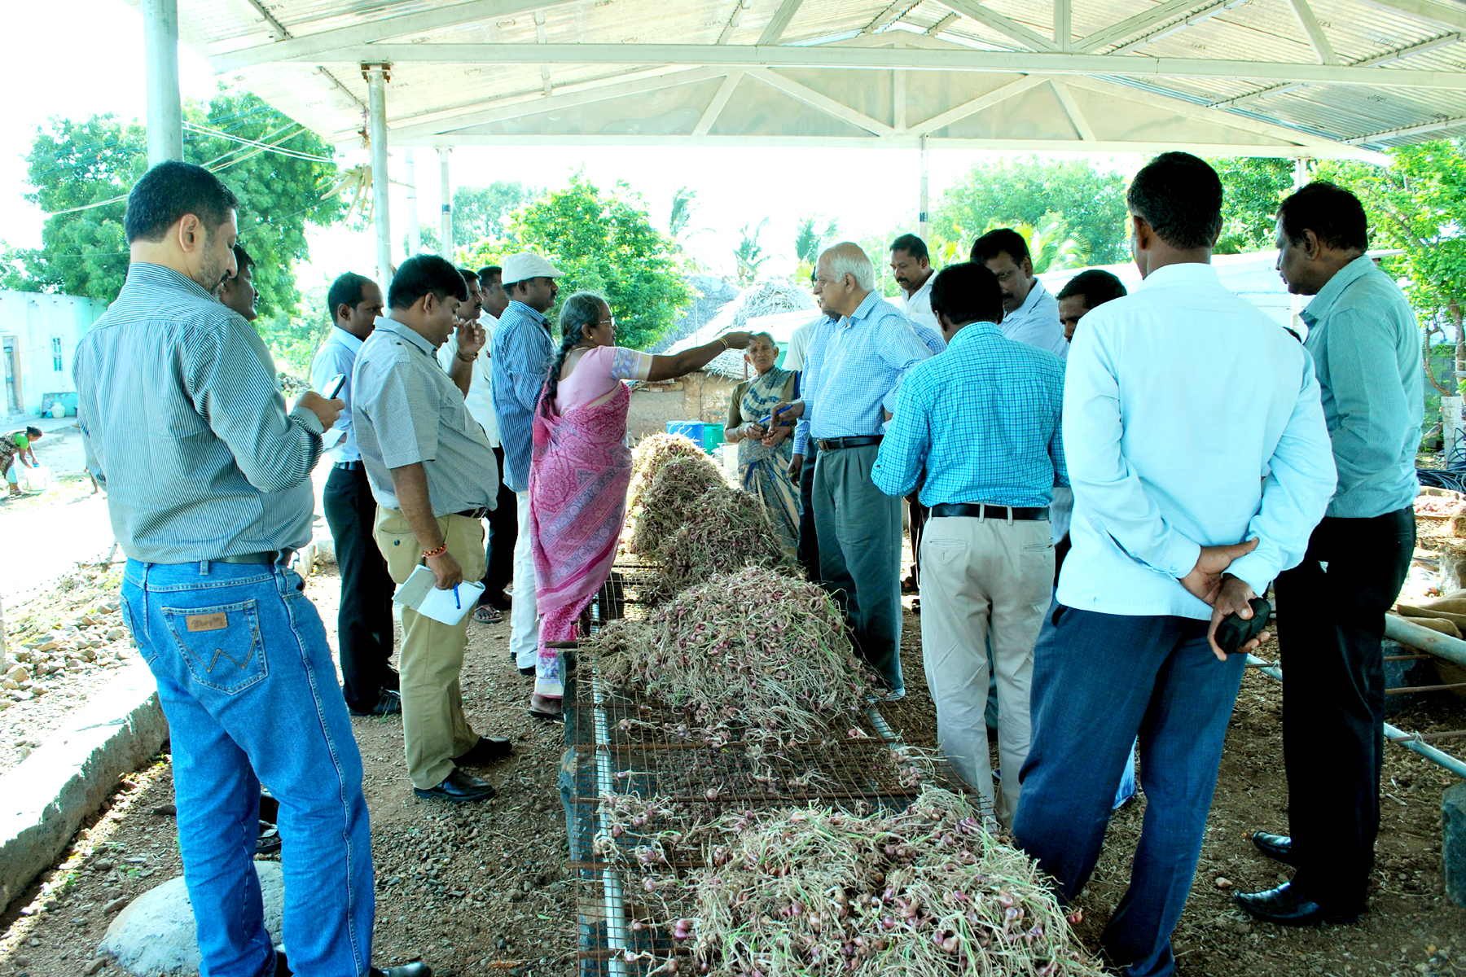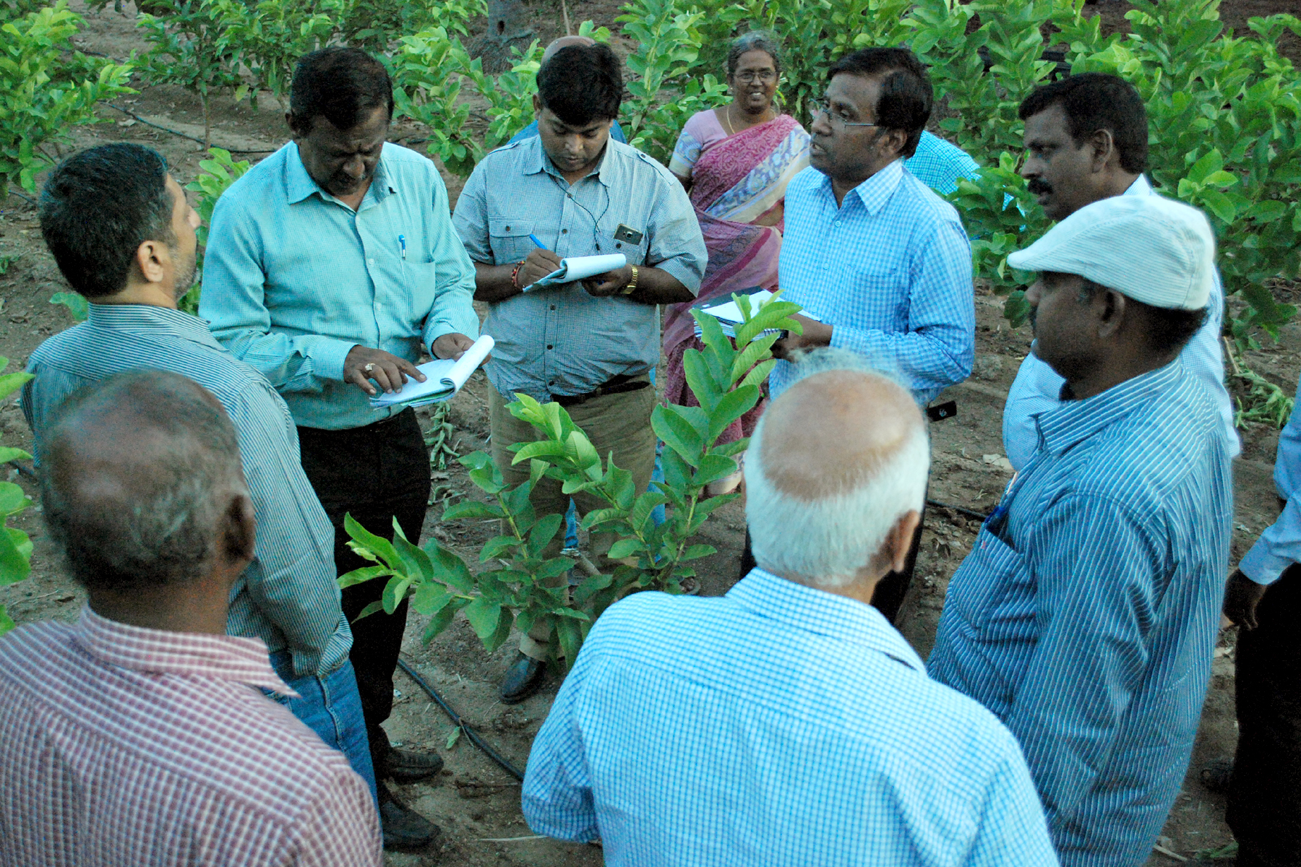

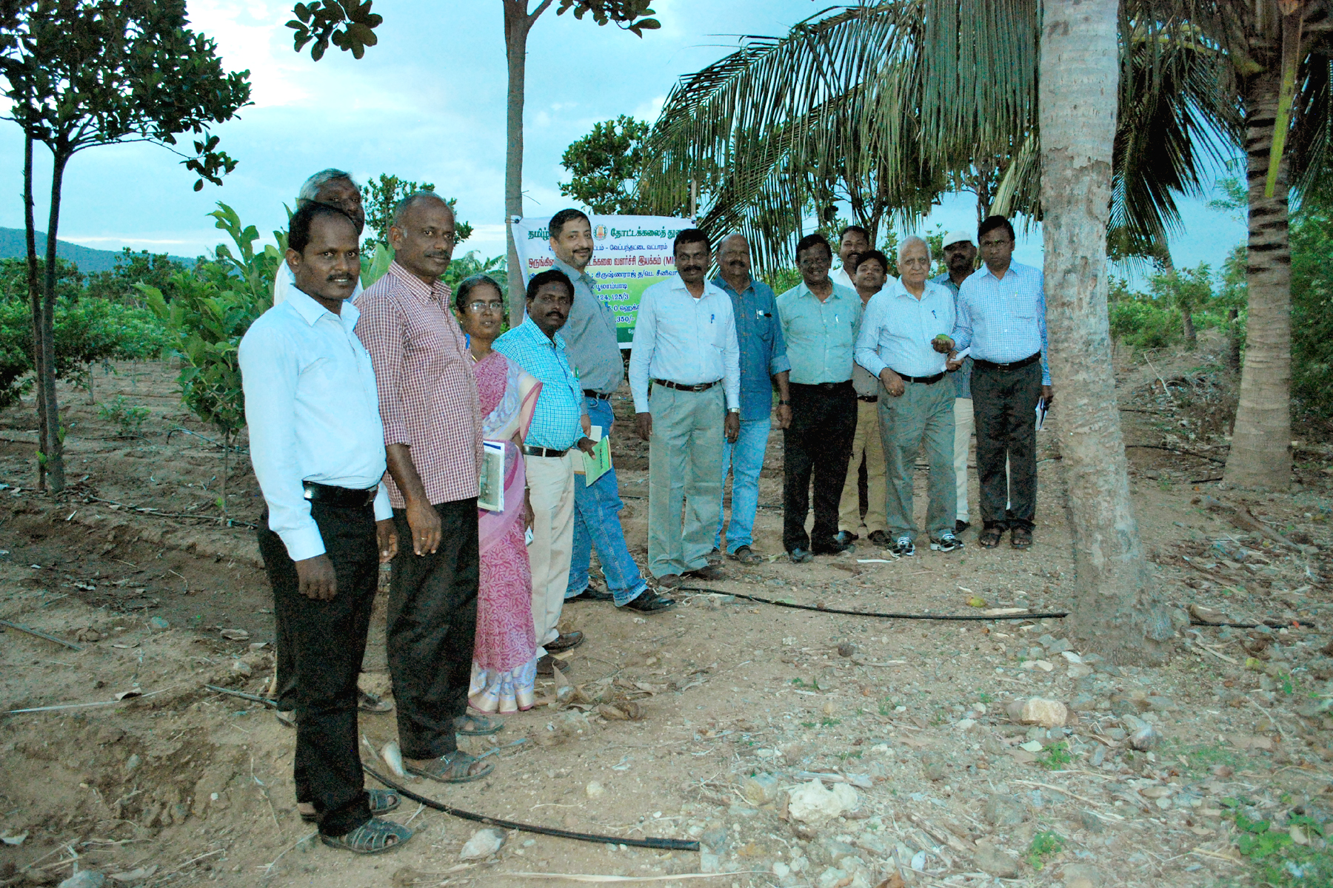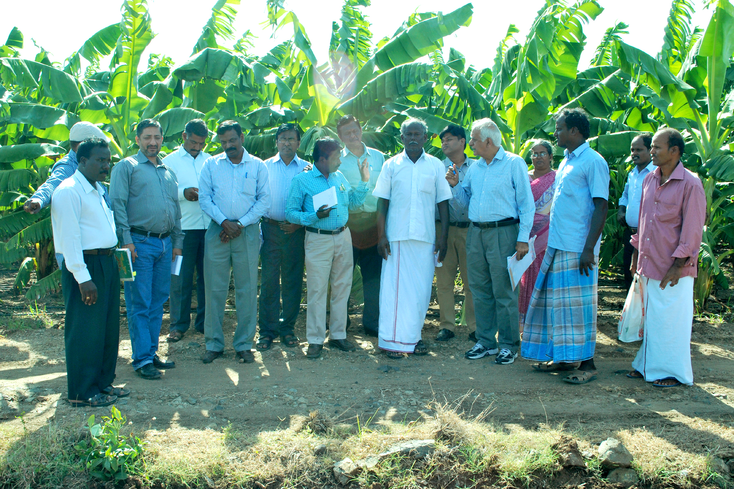

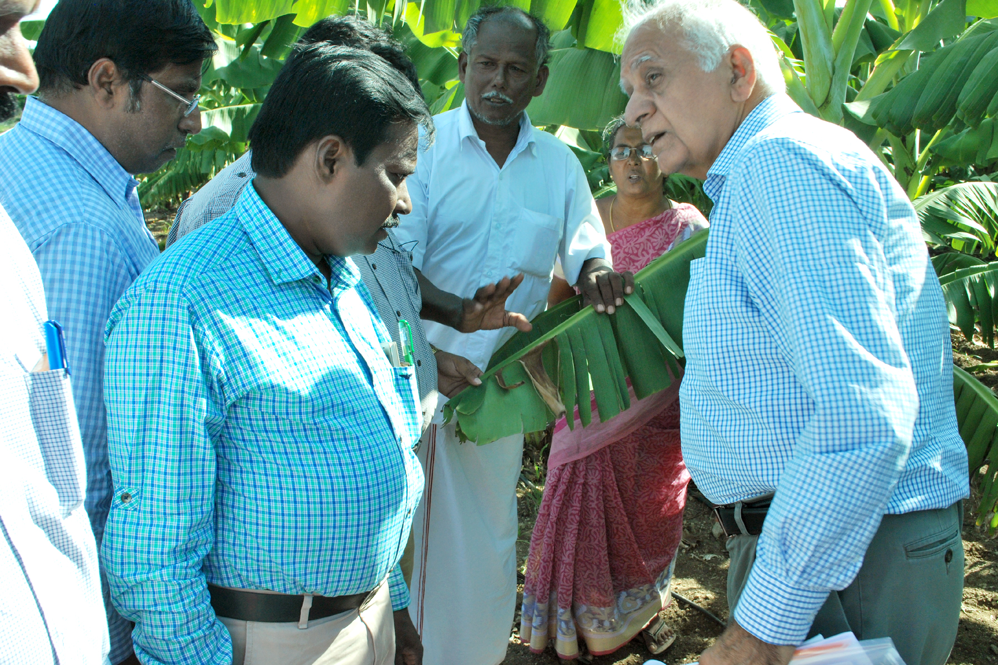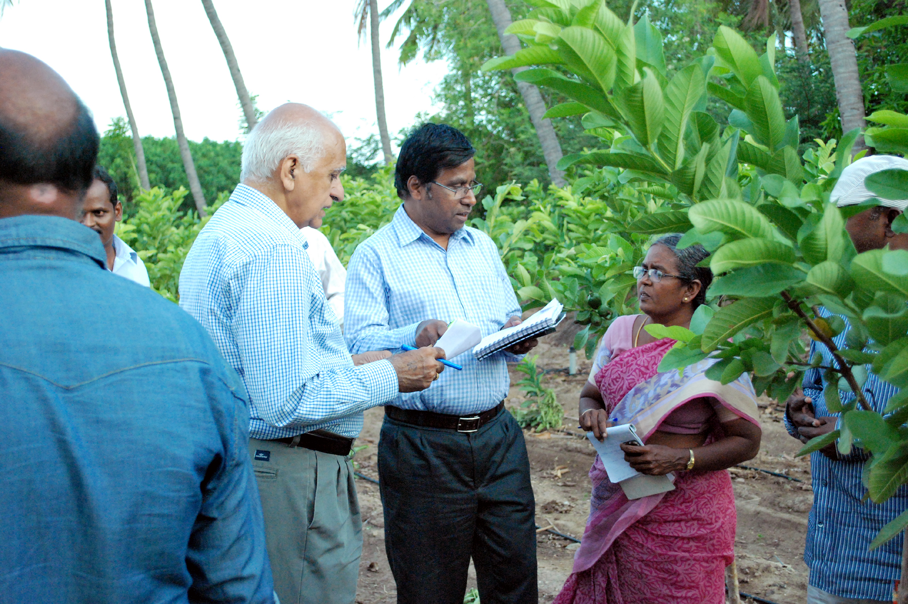

DISTRICT: CUDDALORE

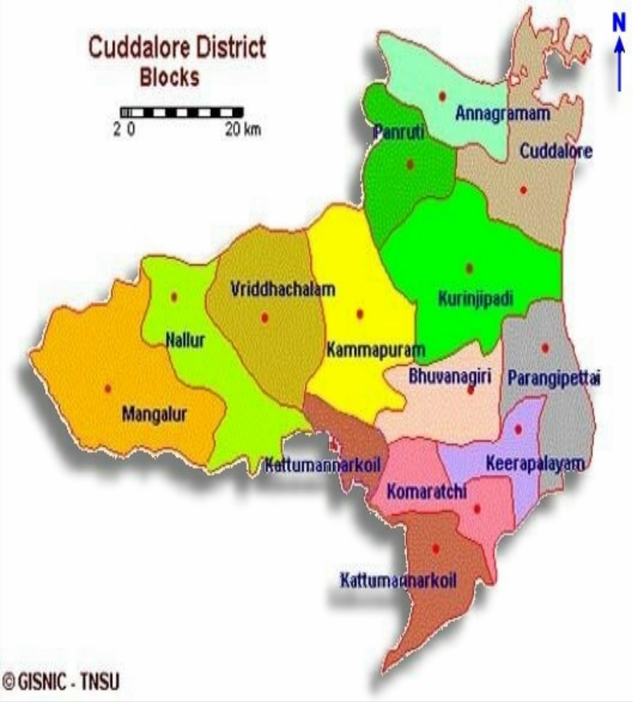

INTRODUCTION
The District is predominantly Agriculture in nature coastal line of 57.7km stretching from Cuddalore in North.
- The boundaries of the district are
- Bay of Bengal in the East.
- Villupuram District in the West.
- Puducherry union Territory in the North.
- Nagapattinam District in the South
AGRO CLIMATE ZONE
Cuddalore district comes under North- Eastern and Cauvery Delta Zone (Part of Cuddalore district-5 Blocks).
SOIL TYPE
- The soil permeation of the district is the combination of red soil, red loam, clay loam and sandy loam.
- Red soil is found in Panruti taluk.
- Clay loam & red loam are found in Chidambaram, Vridhachalam and Cuddalore taluk

GEOGRAPHICAL FEATURES:

Cuddalore district is predominantly agricultural district with the coastal line stretching from Puducherry Union Territory in the North to the mouth of the river Coleroon in the South. The total geographical area of the district is 4283 sq.km. with the coastal line of 68 Kms. The boundaries of the district are:
East: Bay of Bengal
West: Villupuram district
North: Union Territory of Puducherry

List of Taluks and Blocks in Cuddalore district
Taluks | Blocks
- Chidambaram  - Cuddalore  - Kattumannarkoil  - Panruti  - Tittakudi  - Kurinjipadi  - Virudhachalam  - Veppur | - Annagramam  - Melbhuvanagiri  - Cuddalore  - Kammapuram  - Kattumannarkoil  - Keerapalayam  - Kumaratchi  - Kurinjipadi  - Mangalore  - Nallur  - Panruti  - Parangipettai  - Virudhachalam

LAND USE PATTERN

Total Geographical Area (Ha.) |  | 3,67,781
1 | Forest | 1,415
2. | Barren and uncultivable waste | 14,647
3. | Land put to Non-Agri use | 58,557
4. | Cultivable waste land | 6,039
5. | Permanent pasture and other grass land | 608
6. | Misc. tree crops and grooves not included in the net area sown | 19,040
7. | Current fallow | 36,164
8. | Other than current fallow | 15,163
9. | Net area sown | 2,16,148
 | Total | 3,67,781

RAINFALL PATTERN IN 2013(mm)

Sl.No. | Season | Normal | Percentage %
1. | Winter(Jan-Feb) | 48.6 | 4
2. | Summer (Mar-May) | 99.8 | 7
3. | South West monsoon(June-Sept) | 392.4 | 30
4. | North East Monsoon(Oct-Dec) | 773.7 | 59
Total |  | 1314.5 | 100

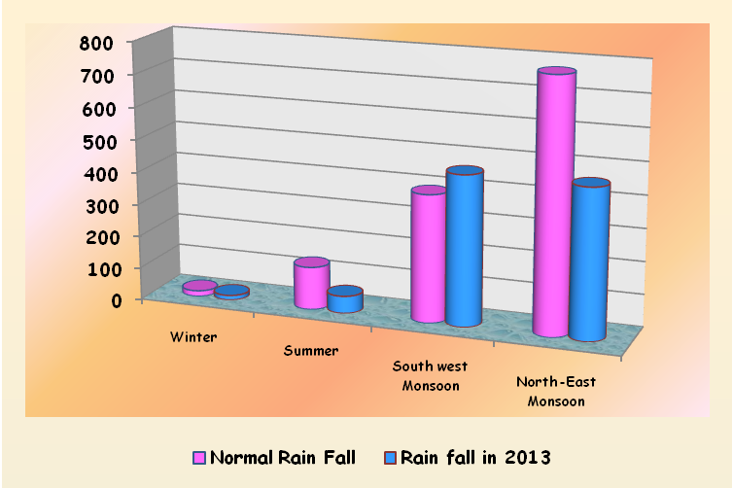

DIFFERENT SOURCES OF IRRIGATION IN CUDDALORE
S.No | Sources | Number | Net Area Irrigated (ha) | Percentage | Gross Area Irrigated (ha)
1 | Dug wells | 10643 | 9217 | 6.45 | 9365
2 | Tube wells | 36305 | 80220 | 56.11 | 100736
3 | Tanks | 592 | 5723 | 4.00 | 6690
4 | Canals | 270 | 47099 | 32.94 | 50119
5 | Other sources | 21 | 704 | 0.49 | 1151
 | Total |  | 1,42,963 | 100.00 | 1,68,061

Source: Season and crop report, department of economics and statistics Tamil Nadu

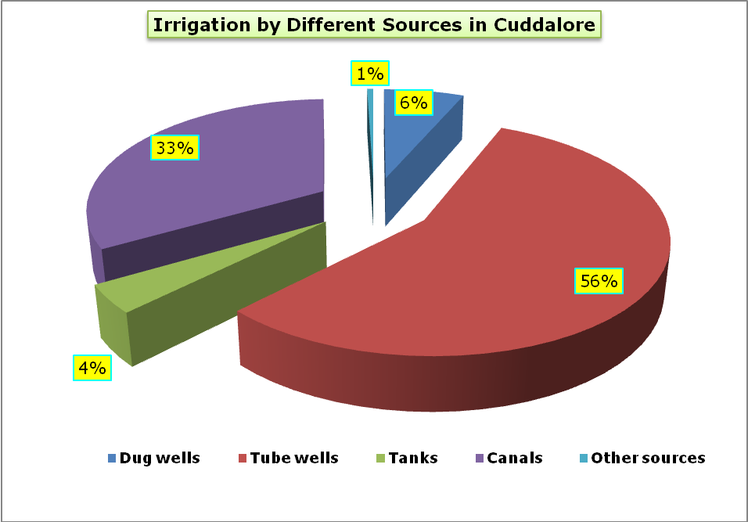

TOTAL CULTIVABLE AREA UNDER HORTICULTURE

1. | Total geographical area | 3,67,781 Ha.
2. | Net area sown | 2,16,148 Ha.
3. | Total area under horticulture crops | 44,830 Ha.
4. | % of Horticulture crops to total geographical area | 12.19 %
5. | % of Horticulture crops to net area sown | 20.74 %

AREA COVERAGE UNDER HORTUCULTURE CROPS FOR THE LAST FOUR YEARS

Area Coverage 2011-12, 2012-13, 2013-14 & 2014-15
Sl. No | Name of the Crop | Normal Area | Area Coverage (in Ha.)
Sl. No | Name of the Crop | Normal Area | 2011-12 | 2012-13 | 2013-14 | 2014-15
I | VEGETABLES
1 | Brinjal | 350 | 507 | 350 | 424 | 445
2 | Bhendi | 925 | 155 | 925 | 415 | 365
3 | Bittergourd | 25 | 122 | 25 | 163 | 158
4 | Snakergourd | 20 | 108 | 20 | 34 | 29
5 | Onion | 10 | 7 | 10 | 9 | 60
6 | Lablab | - | 18 | - | 0 | 0
7 | Drumstick | - | 124 | - | 24 | 32
8 | Tomato | - | - | - | 0 | 3
 | Total | 1330 | 1041 | 1330 | 1069 | 1092
II | FRUITS
1 | Banana | 4000 | 4400 | 4000 | 3937 | 3486
2 | Mango | 850 | 669 | 850 | 918 | 729
3 | Jackfruit | 650 | 840 | 650 | 0 | 0
4 | Guava | 700 | 512 | 700 | 1186 | 1251
5 | Lemon | 50 | 18 | 50 | 0 | 0
6 | Sapota | 10 | - | 10 | 0 | 0
 | Total | 6260 | 6439 | 6260 | 6041 | 5466

AREA COVERAGE UNDER HORTUCULTURE CROPS FOR THE LAST FOUR YEARS

Area Coverage 2011-12, 2012-13, 2013-14 & 2014-15
Sl. No | Name of the Crop | Normal Area | Area Coverage (in Ha.)
Sl. No | Name of the Crop | Normal Area | 2011-12 |  | 2012-13 | 2013-14 | 2014-15
III | FLOWERS
1 | Mullai | 475 | 583 |  | 475 | 280 | 313
2 | Crossandara | 30 | 6 |  | 30 | 62 | 44
3 | Marigold | 45 | 15 |  | 45 | 32 | 76
4 | Tuberose |  |  |  |  | 28 | 32
 | Total | 550 | 604 |  | 550 | 402 | 465
IV | PLATATION CROPS AND OTHER CROPS
1 | Cashew | 32300 | 30418 |  | 32300 | 32788 | 33077
2 | Betelvine | - | 36 |  | - | 0 | 0
3 | Bamboo | - | 48 |  | - | 0 | 0
4 | Medicinal Plants | - | 86 |  | - | 0 | 0
5 | Cocoa | - | - |  | - | 0 | 44
6 | Tamarind | - | - |  | - | 211 | 161
 | Total | 32300 | 30588 |  | 32300 | 32999 | 33282
V | SPICES AND CONDIMENTS
1 | Chillies | 130 | 60 |  | 130 | 124 | 211
2 | Turmeric | 160 | 658 |  | 160 | 310 | 332
3 | Coriander | 30 | 12 |  | 30 | 6 | 0
4 | Tapioca | 3950 | 4182 |  | 3950 | 3566 | 3892
5 | Sweet potato | - | - |  | - | 0 | 90
6 | Watermelon | 120 | 194 |  | 120 | 0 | 0
 | Total | 4390 | 5106 |  | 4390 | 4006 | 4525
 | Grand Total | 44830 | 43778 |  | 44830 | 44517 | 44830
FIELD VISIT
Beneficiary No-1
Area Expansion / Rejuvenation
Sl. No. | Details |  |  | Remarks
1 | Name & Address of Beneficiary whose field visited |  |  | K. Sivaganam S/o.Krishnan, Mathakilirmanickam, Kattumannorkoil Block
2 | Total land available with the beneficiary (Ha.) |  |  | 1.00Ha.
3 | Crop Culster under which covered |  |  | Flowers
4 | Name & Variety of crop planted |  |  | Tuberose
5 | Source of planting material |  |  | Owen
6 | Number of planting material
7 | Number of plants planted/ rejuvenated
8 | Date of plants which survived (also indicate percentage survival)
9 | Total amount of subsidy asistance due to the beneficiary as (Rs.) |  |  | Rs.37,500/- (back-ended)
10 | Amount paid and date of payment |  |  | Apr-15
11 | Mode of payment |  |  | ECS to Bank farmer account
12 | Source of irrigation water (borewell/ Tubewell/Canel) |  |  | Bore well
13 | Whether Drip/ Sprinkle System in use |  |  | Drip
14 | Other inputs provided |  |  | No
15 | whether assistance available for organic farming |  |  | No
16 | If so, area covered
17 | Assistance available
18 | Available marketing facility for the crop |  |  | Flower market nearby town
19 | Other infrastructure available in the vicinity
20 | General upkeep of the plot Very good/ Good/ Average/ Poor |  |  | Very good
21 | Any other relevant observation by the JIT

Observations:
- The field has been maintained well
- Thicker size mulch sheets should be laid for long life.
- Bio control measures for crop protection to be taken up.

Beneficiary No-2
Micro Irrigation

Sl. No. | Details | Remarks
1 | Name & Address of Beneficiary whose field visited | C. Iyyappan S/o.Chinnathambi, Oriyur, Annagrammam Block
2 | Total land available with the beneficiary (Ha.) | 2.00ha.
3 | Type of MI system availed Drip/ Sprinkler | Drip
4 | Crop(s) Covered | Flowers & Vegetables
5 | Total area covered(ha) | 2.00ha.
6 | Crop spacing (for drip) | 1.5m x 0.6m
7 | Year of establishment | 2013-14
8 | Name of Manufacture/ Supplier | Netafim Irrigation Ltd.,
9 | Total subsidy paid & date of payment | Rs.60,840/- June 2014
10 | Mode of payment | ECS to Bank
11 | Status of crop | Flowers @ flowering stage
12 | General upkeep (Very good/ Good/ Average/ Poor) | Very Good
13 | Any other relevant observation by the JIT

Observations:

- Four farmers are jointly marketing marigold which is highly appreciated.

- The drip system was installed as per the norms.

- Farmer has changed the traditional paddy cultivated land to horticultural cropping system with marigold, moringa and cucurbitaceous vegetables.

Beneficiary No-3
Micro Irrigation

Sl. No. | Details | Remarks
1 | Name & Address of Beneficiary whose field visited | R. Vaithiyanathsamy S/o.Ramachandran, Keezhur, Kurinjipadi Block
2 | Total land available with the beneficiary (Ha.) | 4.00ha.
3 | Type of MI system availed Drip/ Sprinkler | Drip
4 | Crop(s) Covered | HDP - Cashew
5 | Total area covered(ha) | 4.00ha.
6 | Crop spacing (for drip) | 5m x 4m
7 | Year of establishment | 2014-15
8 | Name of Manufacture/ Supplier | Netafim Irrigation Ltd.,
9 | Total subsidy paid & date of payment | Rs.1,50,213/- June 2015
10 | Mode of payment | ECS to Bank
11 | Status of crop | One year old crop - vegetative growth
12 | General upkeep (Very good/ Good/ Average/ Poor) | Very Good
13 | Any other relevant observation by the JIT

Observations:

- The layout and drip system installed is good

- Short duration vegetable crops may be cultivated as intercrop for effective utilization of land.

Beneficiary No-4
Protected cultivation

Sl. No. | Details | Remarks
1 | Name & Address of Beneficiary whose field visited | M. Vetrivel S/o.Muthu, Mathakalirmanickam, Kattumannorkoil Block
2 | Total land available with the beneficiary (Ha.) | 2.00 Ha.
3 | Type of protected cultivation activity (Mulching) | Mulching
4 | Year of establishment | 2014-15
5 | Size of structure (Sq.m) | 1.00 Ha
6 | Total cost | Rs.32,000/-
8 | Total subsidy paid and date of payment | Rs.10,000/-
9 | Crop being grown | Tuberose
11 | Condition of Crop | Good
12 | Tie up with market | Yes
13 | General upkeep (Very good/ Good/ Average/ Poor) | Very Good
14 | Any other relevant observation by the JIT

Observations:

- The establishment is well

- Selection quality and nematode free planting material should be used in future.

Beneficiary No-5
FARM MECHANISATION

Sl. No. | Details | Remarks
1 | Name of the project | NHM - Farm Mechanisation
2 | Year of implementation | 2014-15
3 | Name of beneficiary | T. Latha W/o.Thirumalai
4 | Location of project | Vazhapattu, Annagrammam Block
5 | Name of Machinery | Tractor < 20 hp
6 | Make | Mitsubsi
5 | Total cost of machinary | Rs.3.30 lakhs
6 | Amount released & date | Rs.1.00 lakhs/ June 2015

Observations:

- The mini tractor is effectively utilized for horticultural crops cultivation (Banana and Tapioca).

- For optimum utilization of machinery the farmer is planning to go for custom hiring.

Beneficiary No-6
FARM MECHANISATION

Sl. No. | Details | Remarks
1 | Name of the project | NHM - Farm Mechanisation
2 | Year of implementaiton | 2014-15
3 | Name of beneficiary | A. Pasupathy S/o.Arunachalam
4 | Location of project | Nathamedu, Annagrammam Block
5 | Name of Machinery | Tractor < 20 hp
6 | Make | Mitsubsi
5 | Total cost of machinary | Rs.3.30 lakhs
6 | Amount released & date | Rs.1.00 lakhs/ June 2015

Observations:

- The farmer is completely utilizing the tractor in his own fields and this has solved his problem pertaining to non availability of farm labourers.

- The farmer was suggested to get trailer and bund former for effective utilization.

Beneficiary No-7
FARM MECHANISATION

Sl. No. | Details | Remarks
1 | Name of the project | NHM - Farm Mechanisation
2 | Year of implementation | 2013-14
3 | Name of beneficiary | P. Babu S/o.Perumal
4 | Location of project | Chinnakanadi, Kurinjipadi Block
5 | Name of machinery | Tractor < 40 hp
6 | Make | HMT-Tractor
5 | Total cost of machinery | Rs.5.210 lakhs
6 | Amount released & date | Rs.1.50 lakhs/ April 2015

Observations:

- The tractor is effectively utilized for banana and cassava cultivation.

- The assistance provided to farmer under NHM need to be displayed on the tractor.

Beneficiary No-8
FARM MECHANISATION

Sl. No. | Details | Remarks
1 | Name of the project | NHM - Farm Mechanisation
2 | Year of implementation | 2013-14
3 | Name of beneficiary | R. Dhanachnamurthy S/o.Ramanujam
4 | Location of project | Chinnakanadi, Kurinjipadi Block
5 | Name of machinery | Tractor < 40 hp
6 | Make | HMT-Tractor
5 | Total cost of machinery | Rs.5.210 lakhs
6 | Amount released & date | Rs.1.50 lakhs/ April 2015

Observations:

- The tractor is effectively utilized for vegetables cultivation.

- The details of assistance provided to farmer under NHM need to be displayed on the tractor.

CUDDALORE DISTRICT - FIELD VISIT PHOTOS

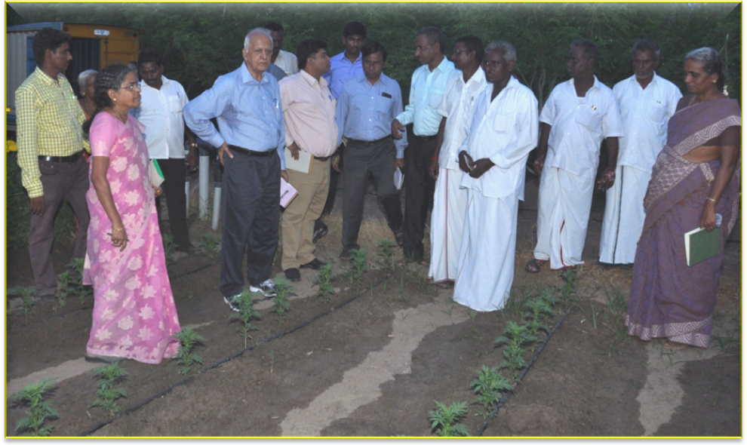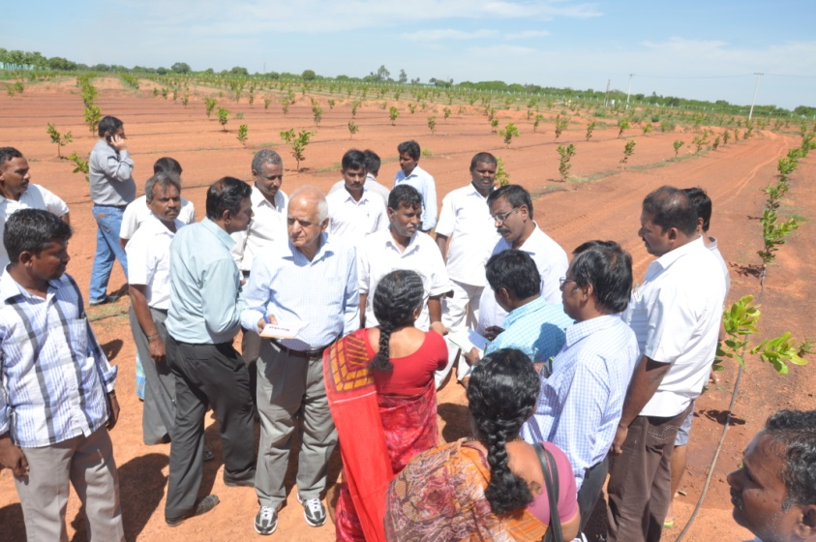

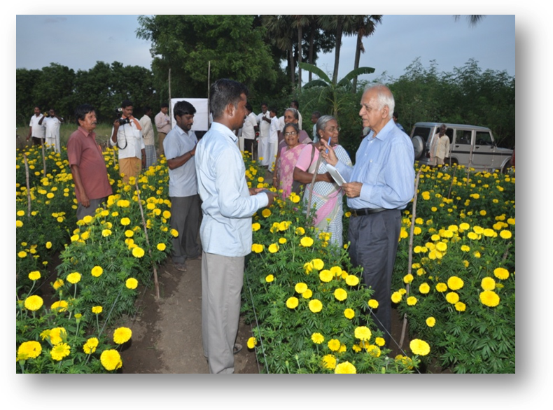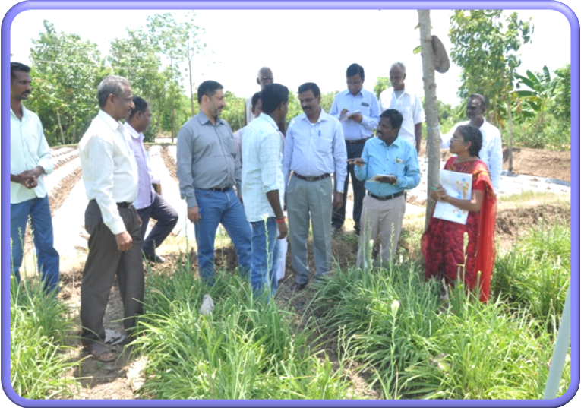

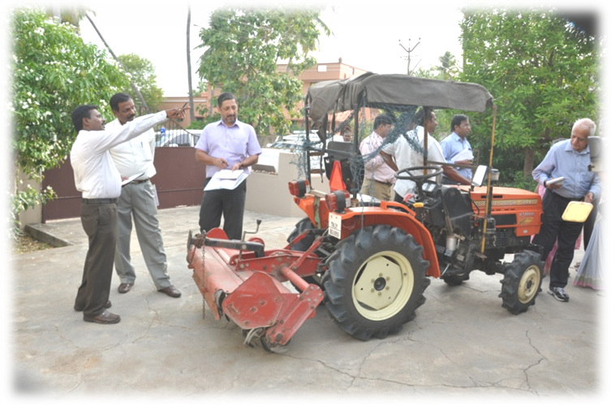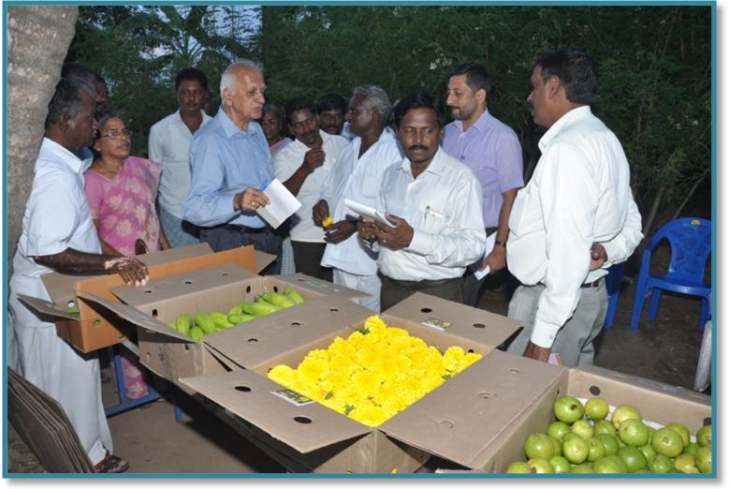

DISTRICT: ARIYALUR

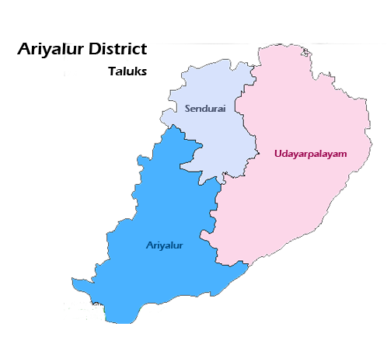
District Profile
Ariyalur district lies in the South Indian state of Tamil Nadu, located at a distance of 310 km from the state capital Chennai. Ariyalur was a part of the Tiruchirappalli district until 1995, Perambalur district until 2007 and subsequently a part of the newly formed Ariyalur district.
It is bounded on the North by Cuddalore, South by Thanjavur, East by Cuddalore and Thanjavur and West by Perambalur and Tiruchirapalli districts. It is an inland district without any coast line. The District has Vellar River in the North and Kollidam River in the South and it has no well marked natural divisions. Ariyalur district situated at between 11°8′14″ North Latitude and 79°4′40″ East Longitude.
Climate
Ariyalur District has dry weather with maximum and minimum temperature ranging between 40° C and 22°C
Soil Types:
Loamy soil, Black soil, Alluvial soil, Sandy loam and Sandy clay are the soil types found in the district
Rainfall:
Season | Rainfall (mm)
Winter | 16.80
Summer | 109.50
South West Monsoon | 238.40
North East Monsoon | 602.20
Grand Total | 966.90
Major Horticulture Crops:
Major Horticulture crops cultivated in this district are fruits crops like Mango, Banana, Guava, Aonla And Jack, Plantation Crops Like Cashew, Vegetables Like Tomato, Brinjal, Bhendi, Onion, Chillies, Tapioca And Watermelon, Spices Like Turmeric, Medicinal Plants Like Gloriosa And Flowers Like Tube Rose, Jasmine, Crossandra And Chrysanthemum
The total fallow land in the district stood as 24974 ha. as stated below:
1 | Fallow lands suitable for agriculture | 3218 Ha.
2 | Current fallow | 13413 Ha
3 | Other fallows | 8343 Ha
 | Total | 24974 Ha
The Net area sown works out to be 102067 lakhs hectares. Among this total area horticulture crops area is 34317 ha. The details are furnished as below:
Sl.No. | Crop | Area in Ha.
1 | Fruits | 858
2 | Vegetables | 2346
3 | Flowers | 142
4 | Plantation crops | 30098
5 | Spices & condiments | 745
6 | Medicinal & aromatic plants | 128
 | Total | 34317

FIELD VISIT
Beneficiary No-1
Area Expansion / Rejuvenation - 1

S. No. | Details | Remarks
1 | Name & address of beneficiary whose field visited. | P. Paramasivam  S/o Periyasamy  Govindhapuram
2 | Total land available with the beneficiary (ha). | 2.00 Ha
3 | Crop cluster under which covered. | NHM
4 | Name & variety of crop planted. | TC Banana – Grand naine
5 | Source of planting material. | Grow more Biotech, Hosur
6 | Number of planting material. | 1675 Nos
7 | Number of plants planted/ rejuvenated. | 1675 Nos
8 | Date of plants which survived (also indicate percentage survival). | 90%
9 | Total amount of subsidy assistance due to the beneficiary as (Rs.) | Rs. 18,720/-
10 | Amount paid and date of payment. | 07.09.2015
11 | Mode of payment. | RTGS
12 | Source of Irrigation Water (Bore well/ Tube well/ Canel) | Bore well
13. | Whether Drip/ Sprinkle System in use. | NO
14. | Other inputs provided. | NO
15. | Whether assistance available for Organic Farming | NO
16 | If so, area covered | -
17. | Assistance available
18. | Available marketing facility for the crop. | Local market
19. | Other infrastructure available in the vicinity. | -
20. | General upkeep of the plot;  Very good/ Good / Average/ Poor.
21. | Any other relevant observation by the JIT.

Observations:

- The initiative of TC Banana introduction by the farmer is appreciated.
- 30 percent mortality to be made good with gap filling.
- The field to be irrigated and fertilized as per the schedule.

Beneficiary No-2
Area Expansion / Rejuvenation

S. No. | Details | Remarks
1 | Name & address of Beneficiary whose field visited. | K. Meenakumari  W/o Krishnan  Keelapalur
2 | Total land available with the beneficiary (ha). | 4.00 Ha
3 | Crop Cluster under which covered. | NHM
4 | Name & variety of crop planted. | Mango – Banganapalli, Bangalura  Acidlime - Kodur
5 | Source of planting material. | Mango – SHF, Marunkulam  Acidlime - Own
6 | Number of planting material. | Mango – 200  Acidlime - 220
7 | Number of plants planted/ rejuvenated. | Mango – 200  Acidlime - 220
8 | Date of plants which survived (also indicate percentage survival). | 90%
9 | Total amount of subsidy assistance due to the beneficiary as (Rs.) | NHM - Rs. 16800/- (Mango & acidlime)
10 | Amount paid and date of payment. | -
11 | Mode of payment. | RTGS
12 | Source of Irrigation Water (Bore well/ Tube well/ Canel) | Farmpond
13. | Whether Drip/ Sprinkle System in use. | Yes
14. | Other inputs provided. | NO
15. | Whether assistance available for Organic Farming | NO
16 | If so, area covered | -
17. | Assistance available
18. | Available marketing facility for the crop. | Local market
19. | Other infrastructure available in the vicinity. | -
20. | General upkeep of the plot;  Very good/ Good / Average/ Poor.
21. | Any other relevant observation by the JIT.

Observations:
- Proper training operations to be carried out for mango and acid lime.
- The team suggested that gap filling should be completed to maintain the population.
Beneficiary No-3
Area Expansion / Rejuvenation

S. No. | Details | Remarks
1 | Name & address of Beneficiary whose field visited. | K. Selvarasu  S/o Karupan  Melakarupur
2 | Total land available with the beneficiary (ha). | 1.00 Ha.
3 | Crop Cluster under which covered. | NHM
4 | Name & variety of crop planted. | Brinjal - Darpan
5 | Source of planting material. | Through Department
6 | Number of planting material. | Seeds – 50gm
7 | Number of plants planted/ rejuvenated.
8 | Date of plants which survived (also indicate percentage survival). | 98%
9 | Total amount of subsidy assistance due to the beneficiary as (Rs.) | NHM - Rs.5,000/-
10 | Amount paid and date of payment. | -
11 | Mode of payment. | RTGS
12 | Source of irrigation water (Bore well/ Tube well/ Canel) | Bore well
13. | Whether Drip/ Sprinkle system in use. | No
14. | Other inputs provided. | Fertilizers & Plant protection chemicals
15. | Whether assistance available for Organic Farming | NO
16 | If so, area covered | -
17. | Assistance available
18. | Available marketing facility for the crop. | Local market
19. | Other infrastructure available in the vicinity. | -
20. | General upkeep of the plot;  Very good/ Good / Average/ Poor.
21. | Any other relevant observation by the JIT.

Observations:

- The effort done by the farmer pertaining to introduction of F1 hybrid in brinjal is appreciated.

- The farmer has to take effective plant protection measures for pest and diseases.

Beneficiary No-4
Area Expansion / Rejuvenation

S. No. | Details | Remarks
1 | Name & address of Beneficiary whose field visited. | N. Selvarasu  S/o Natesan  Valaivettikupam
2 | Total land available with the beneficiary (ha). | 1.50 Ha.
3 | Crop Cluster under which covered. | NHM
4 | Name & variety of crop planted. | Cashew – VRI 3
5 | Source of planting material. | Through Department, SHF
6 | Number of planting material. | 100 Nos.
7 | Number of plants planted/ rejuvenated. | 100 Nos.
8 | Date of plants which survived (also indicate percentage survival). | 95%
9 | Total amount of subsidy assistance due to the beneficiary as (Rs.) | NHM - Rs.6,000/-
10 | Amount paid and date of payment. | -
11 | Mode of payment. | RTGS
12 | Source of Irrigation Water (Bore well/ Tube well/ Canel) | Bore well
13. | Whether Drip/ Sprinkle System in use. | No
14. | Other inputs provided. | Fertilizers & Plant protection chemicals
15. | Whether assistance available for Organic Farming | NO
16 | If so, area covered | -
17. | Assistance available
18. | Available marketing facility for the crop. | Local market
19. | Other infrastructure available in the vicinity. | -
20. | General upkeep of the plot;  Very good/ Good / Average/ Poor.
21. | Any other relevant observation by the JIT.

Observations:

- The planted VRI3 cashew is established well.

- JITsuggested to follow canopy management for initial framework.

Beneficiary No-5
Area Expansion / Rejuvenation - 5

Sr. No. | Details | Remarks
1 | Name & address of Beneficiary whose field visited. | R. Maharajan  S/o. Rathinam  Silal
2 | Total land available with the beneficiary (ha). | 1.50 Ha.
3 | Crop Cluster under which covered. | NHM
4 | Name & variety of crop planted. | Papaya – Red Lady & mortality replaced by local variety
5 | Source of planting material. | By own
6 | Number of planting material. | 1,250 Nos.
7 | Number of plants planted/ rejuvenated. | 1,250 Nos.
8 | Date of plants which survived (also indicate percentage survival). | 98%
9 | Total amount of subsidy assistance due to the beneficiary as (Rs.) | NHM - Rs.11,550/-
10 | Amount paid and date of payment. | -
11 | Mode of payment. | RTGS
12 | Source of Irrigation Water (Bore well/ Tube well/ Canel) | Bore well
13. | Whether Drip/ Sprinkle System in use. | No
14. | Other inputs provided. | No
15. | Whether assistance available for Organic Farming | NO
16 | If so, area covered | -
17. | Assistance available
18. | Available marketing facility for the crop. | Local market
19. | Other infrastructure available in the vicinity. | -
20. | General upkeep of the plot;  Very good/ Good / Average/ Poor.
21. | Any other relevant observation by the JIT.

Observations:

- The new introduction of papaya by the farmer is highly appreciated.

- The production and the earnings by the grower are very good.

Beneficiary No-6
Protected Cultivation

S. No. | Details | Remarks
1 | Name & address of Beneficiary whose field visited. | R. Selvi  W/o Ramalingam  Silal
2 | Total land available with the beneficiary (ha). | 2.00 Ha.
3 | Type of Protected cultivation activity (Hi-tech / Normal GH, Shade net, Plastic tunnel ……..) | Shadenet
4. | Year of establishment | 2013-14
5. | Size of Structure (Sq. m) | 1000 Sq.m
6. | Total cost | Rs.6,00,000/-
7. | Agency involved in fabrication and installation
8. | Total subsidy paid and date of payment. | Rs.3,55,000/-
9. | Crop being grown | Brinjal, Chillies nursery
10. | Condition of Structure
11. | Condition of Crop
12. | Tie up with market
13. | General upkeep (Very good/ Good/ Average/ Poor)
14 | Any other relevant observation by JIT.

Observations:
- The shade net has been constructed as per the norms.
- The farmer produces quality planting material of chillies and brinjal.
- In future, other F1 hybrids of commercial vegetable seedlings may be produced.

Beneficiary No-7
Protected Cultivation

S. No. | Details | Remarks
1 | Name & address of Beneficiary whose field visited. | V. Devasena  W/o Viswanathan  Silal
2 | Total land available with the beneficiary (ha). | 2.00 Ha.
3 | Type of Protected cultivation activity (Hi-tech / Normal GH, Shade net, Plastic tunnel ……..) | Plastic Mulching
4. | Year of establishment | 2014-15
5. | Size of Structure (Sq. m) | 1 Ha
6. | Total cost | Rs.39,000/-
7. | Agency involved in fabrication and installation
8. | Total subsidy paid and date of payment. | Rs.16,000/-
9. | Crop being grown | Tuberose
10. | Condition of Structure
11. | Condition of Crop
12. | Tie up with market
13. | General upkeep (Very good/ Good/ Average/ Poor)
14 | Any other relevant observation by JIT.

Observations:

- The farmer get remunerative price for tuberose flowers under mulching.

Beneficiary No-8
Post Harvest Management
Pack House/Cold Storage/Ref Van/ Primary processing

Sr. No. | Details | Remarks
1 | Name of the project | Pack house
2 | Year of Implementation | 2014-15
3 | Project Period | 6 months
4 | Name of Beneficiary | K. Meenakumari,  W/o. Krishnan,  Keelapalur.
5 | Location of Project | Keelapalur, Thirumanur Block
6 | Total Project Cost | Rs.5,50,000/-
7 | Amount Released & date | Under construction
8 | Expenditure incurred
9 | Status
 | Capacity of unit
 | Commodity
 | Equipments purchased
 | Condition of infrastructure
 | Whether NHM logo displayed
 | Whether funds disbursed to agency

Observations:

- The pack house is under construction.

- It should be constructed as per the approved design and norms.
Beneficiary No-9
Mechanization
Power tiller

Sr. No. | Details | Remarks
 | Name of the Implement | Power tiller
 | Year of Implementation | 2014-15
 | Name of Beneficiary | S. Arumugam,  S/o. Subburayan,  Thelur
 | Total Cost | Rs.1,62,750/-
 | Amount Released & date | Rs.50,000/-
 | Status
 | Capacity of unit
 | Commodity
 | Equipments purchased
 | Condition of infrastructure
 | Whether NHM logo displayed
 | Whether funds disbursed to agency

Observations:

- The power tiller is effectively utilized for horticultural crops cultivation and other related activities.
Beneficiary No-10

Micro Irrigation

Sr. No. | Details | Remarks
1 | Name & address of beneficiary visited. | K. Meenakumari,  W/o. Krishnan,  Keelapalur.
2 | Total land available with the beneficiary (ha). | 4.00 Ha.
3 | Type of MI system availed Drip/ Sprinkler | Drip
4 | Crop(s) covered | Mango, Amla, Acidlime, Vegetables
5. | Total area covered (ha) | 4.00 ha.
6 | Crop Spacing (for drip) | According to the crop
7 | Year of establishment | 2013-14
8 | Name of Manufacturer/ Supplier | Premier Irrigation
9 | Total subsidy paid & date of payment | Rs.1,45,200/-
10 | Mode of payment | RTGS
11 | Status of crop
12 | General upkeep (Very good/ Good/ Average/ Poor)
13. | Any other relevant observation by JIT.

Observations:
- Drip system is installed well.
- Gap filling to be done in fruit crops.

Ariyalur District - Field Visit Photographs

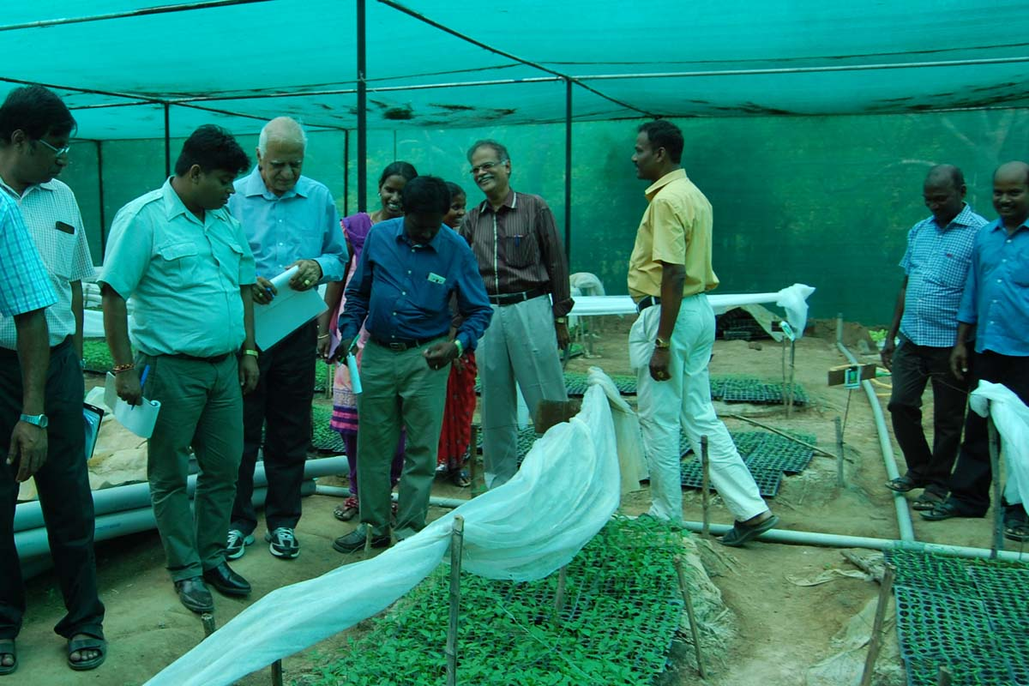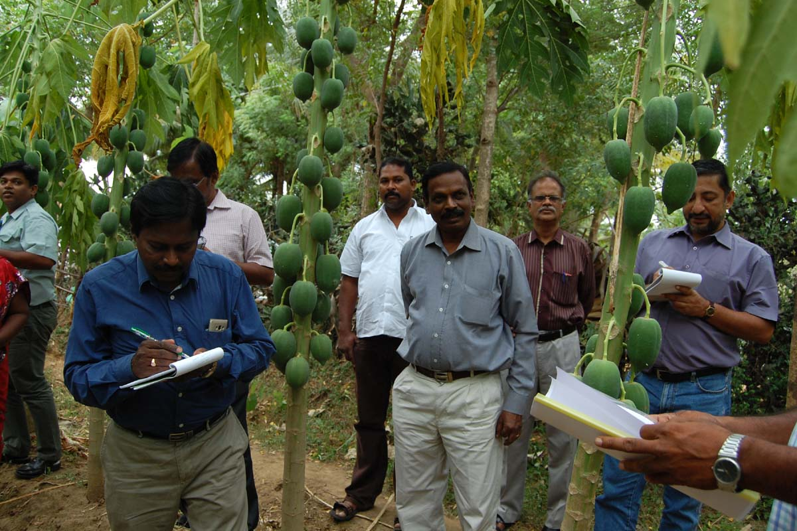

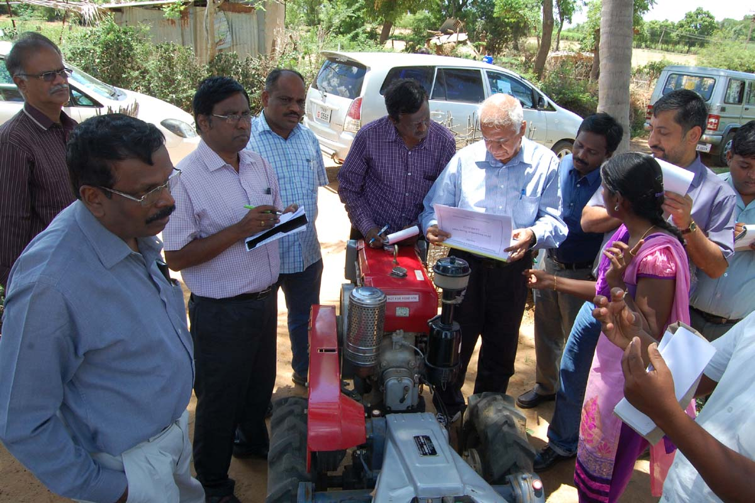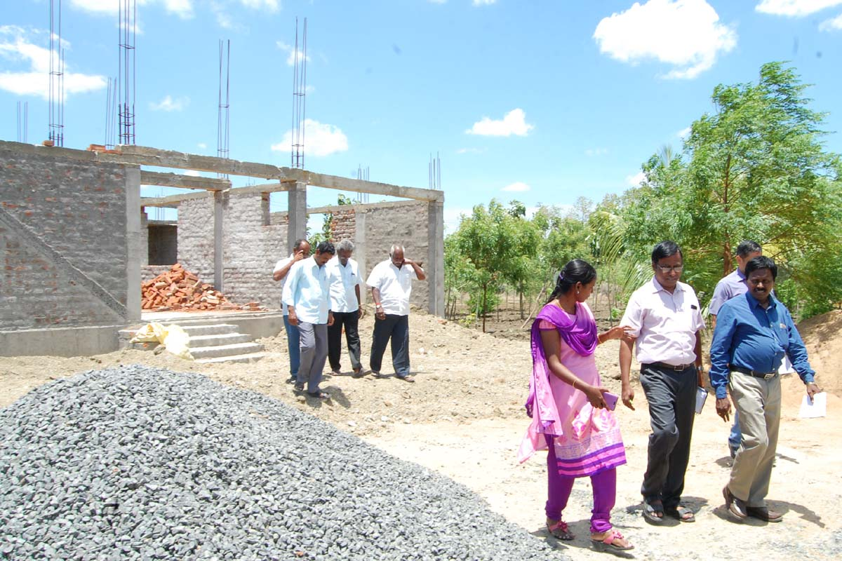

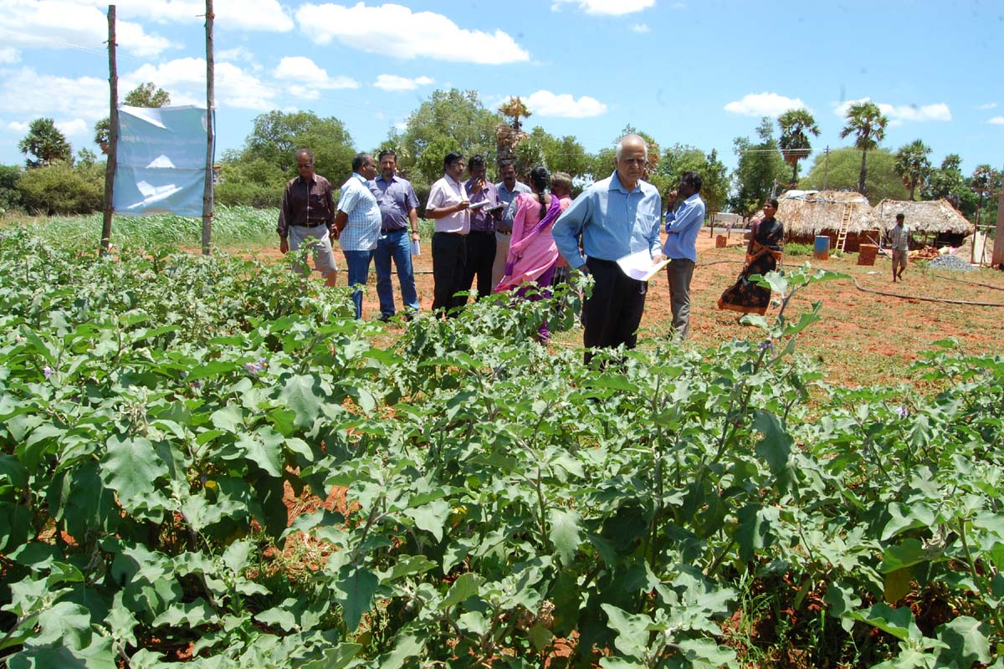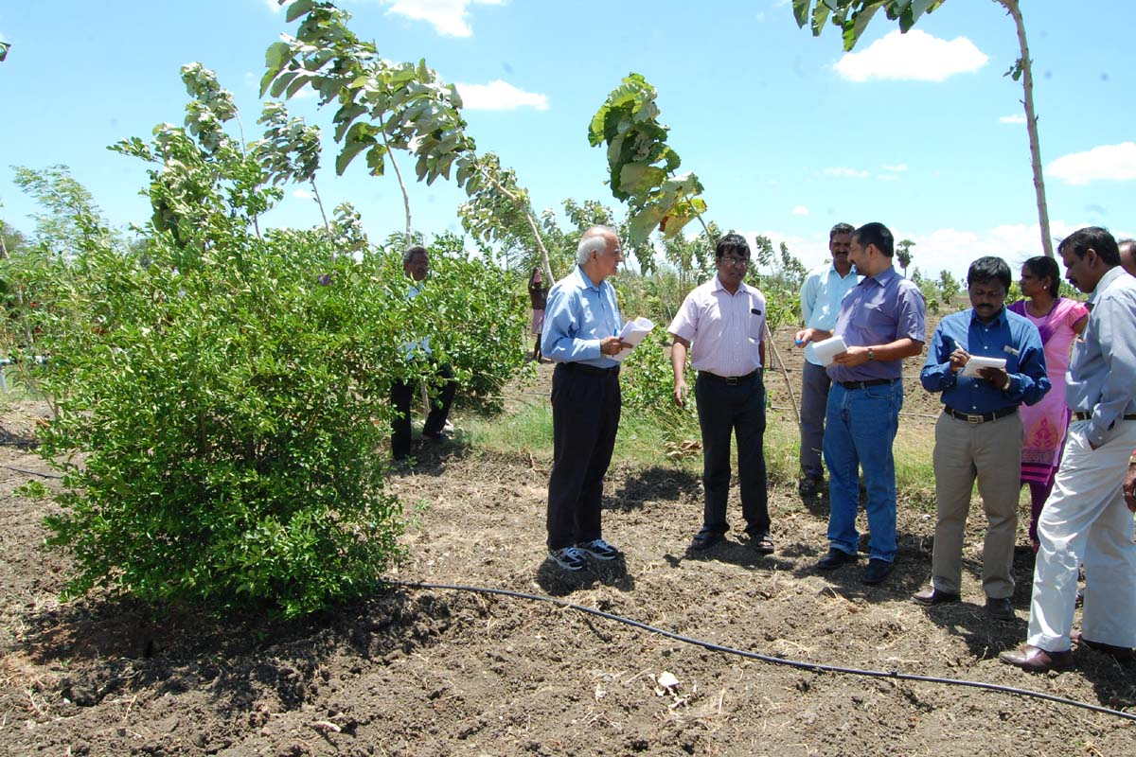

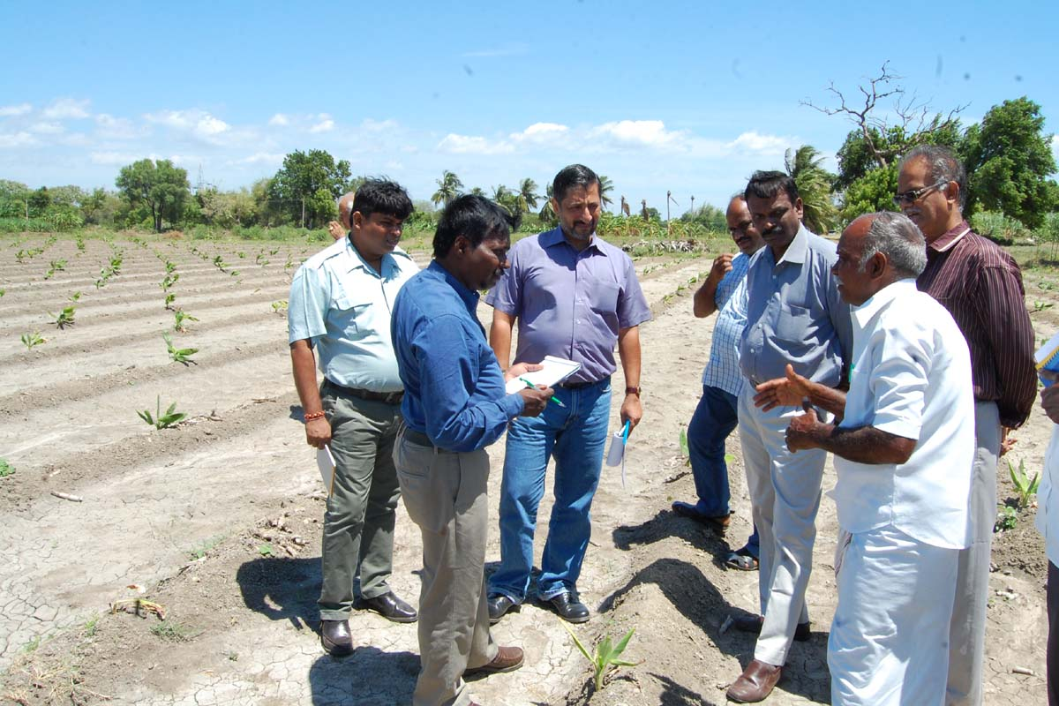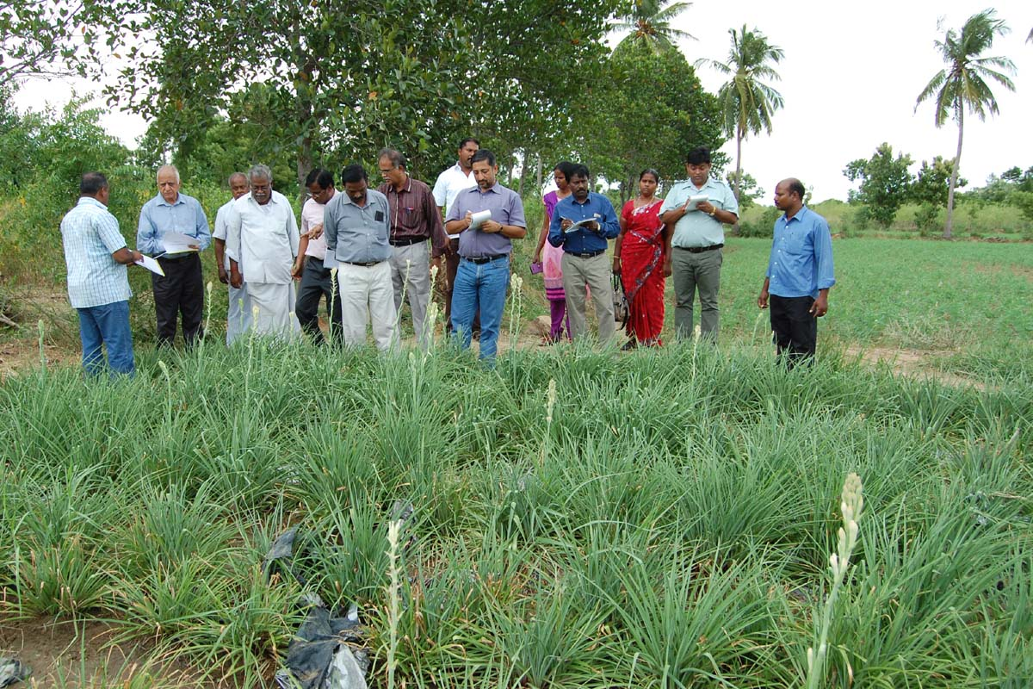

DISTRICT: THANJAVUR

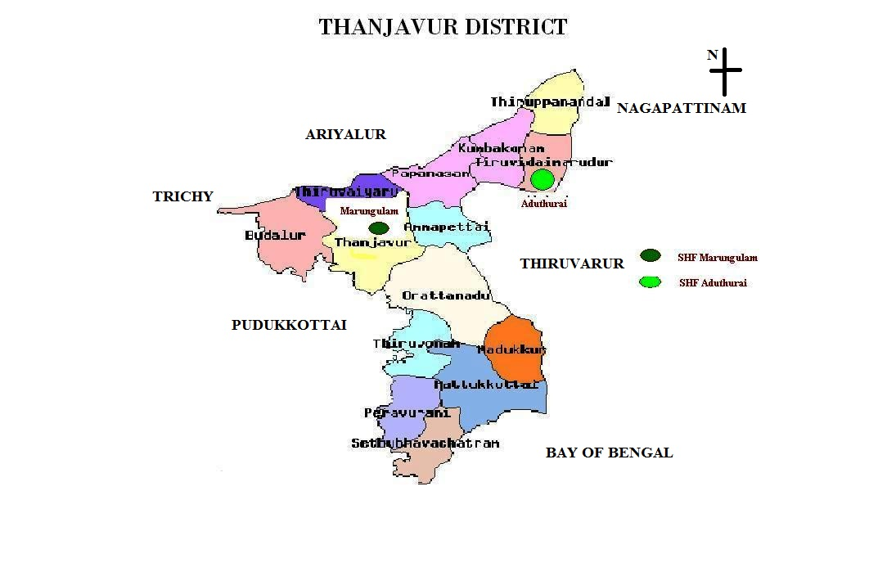

THANJAVUR DISTRICT PROFILE:

- Thanjavur being the foremost district of the Cauvery Delta

- Stands unique from time immemorial for its agricultural activities

- Coastal district abounds in green paddy fields, coconut groves, vast gardens of mango and banana

- Primarily agrarian in nature with very few industrial units.

- The district lies in the East coast of Tamil Nadu. The district is bounded on the north-west by Cauvery River which demarcates itself from Tiruchirapalli, Ariyalur and Cuddalore districts and on the north and east it is bounded by Nagapattinam and Thiruvarur districts and on the south by the Palk Strait and Pudukkottai district and west by Pudukkottai, Trichirapalli districts

- The district has its head quarters at Thanjavur which was once the Kingdom Capital of Raja Raja Cholan.

- CANALS IN THE DISTRICT

- Cavery – It covers Thiruvaiyaru, Papanasam, Kumbakonam and
Thiruvidaimaruthur.

- Vennar – It covers Thanjavur and Papanasam.

- Grand Anaicut Canal – It covers Thanjavur, Orathanadu,
Pattukottai and Peravurani.

DETAILS OF BLOCK, TALUK, FIRKA AND REVENUE VILLAGES
District : THANJAVUR
S.No | Name of the Taluk | Name of the Block | No. of Panchayat Villages
1 | Thanjavur | Thanjavur | 61
2 | Thiruvaiyaru | Thiruvaiyaru | 40
3 | Budalur | Budalur | 42
4 | Orathanadu | Orathanadu | 58
4 | Orathanadu | Thiruvonam | 30
5. | Papanasam | Papanasam | 34
5. | Papanasam | Ammapettai | 46
5. | Papanasam | Thiruppanandal | 44
6 | Kumbakonam | Kumbakonam | 47
7. | Thiruvidaimaruthur | Thiruvidaimaruthur | 48
8. | Pattukottai | Pattukottai | 43
8. | Pattukottai | Madukkur | 33
9. | Peravurani | Peravurani | 26
9. | Peravurani | Sethubhavachatram | 37

SOILS AND TOPOGRAPHY

- Geology:-

The geological formation of Thanjavur district is made up of cretaceous, tertiary and alluvial deposits and the major area is occupied by the alluvial and tertiary deposits.

ii) Soil Type:

Clay soil, Sandy Loam and Sandy Clay Loam.

iii) Soil Colour

Brown coloured soil - 65%
Red soil - 19.3%
Black soil - 15.77%

In Thanjavur district, 13 soil series were identified of which Madukkur, Kalathur, Padugai, Pattukkottai, Adhanur, Vallam series constitute 84% at the extent of 2,76,600 Ha out of 3,23,506 ha

MAJOR SOIL SERIES AND CROPS GROWN

Soil Series | Crops Grown
Madukkur | Groundnut, Gingelly, Paddy, Millets & Chillies
Kalathur | Paddy, Sugar cane, Cotton, Pulses
Padugai | Banana, Sugarcane, Vegetable, flowers, Groundnut, Gingelly
Pattukkottai | Groundnut, Gingelly, Vegetable, Chillies , Coconut, Fruit trees
Adhanur | Paddy, Sugarcane and Cotton
Vallam | Groundnut, Millets, Cashew and Eucalyptus

Among the soil series, the two soil series viz. Padugai series, Pattukkottai series are suitable for Horticulture crops

LAND AND LAND USE PATTERN

The total geographical area of the district is 3,39,657 hectares. The break-up of the total geographical area by land use and their percentage are given below:

Sl.No. | Land Use | Area in Hectares | Percentage of area under Thanjavur District
I | Total geographical area | 3,39,657 | 100%
1. | Forest | 3,426 | 1.0%
2. | Barren and uncultivable waste | 2,201 | 0.6%
3. | Permanent pastures and other grazing lands | 1,746 | 0.5%
4. | Land put to non-agricultural use | 77,122 | 22.8%
5. | Cultivable waste | 10,647 | 3.1%
6. | Land under miscellaneous tree crop and groves/not included in one sown | 6,288 | 1.8%
7. | Current fallows | 8,396 | 2.5%
8. | Other fallows | 26,656 | 7.9%
9. | Net area sown | 2,03,175 | 59.8%
10. | Area sown more than once | 64,675 | 19.0%
11. | Gross cropped area | 2,67,850 | 78.9%

It is noted that 59.8% of the area falls under the net area sown. It is also obvious that Land under forest is much below the state average but this ecological imbalance has to some extent set aside by the land under miscellaneous tree crops and groves of 1.8% which is equal to the state percentage of 1.8.
AVERAGE MONTH-WISE RAINFALL IN THANJAVUR DISTRICT
( In Millimetres)

Name of Season | Month | Normal Rainfall | Average Number of rainy days
South-West Monsoon | June  July  August  September | 39.3  61.1  113.9  106.6 | 1.3  1.1  4.6  2.6
South-West Monsoon | Total | 320.9 | 9.6
North-East  Monsoon | October  November  December | 185.6  210.1  129.5 | 12.5  10.1  4.9
North-East  Monsoon | Total | 525.2 | 27.5
Winter | January  February | 44.4  15.0 | 4.4  4.1
Winter | Total | 59.4 | 8.5
Hot Weather | March  April  May | 18.2  40.4  55.5 | 0.3  2.8  2.5
Hot Weather | Total | 114.1 | 5.6
All seasons |  | 1019.6 | 51.2

SOURCES OF IRRIGATION

Source of irrigation | Extent in Ha | % of the Gross area irrigated
Canals | 136762 | 56.82
Tanks | 345 | 0.14
Tube wells | 42647 | 17.72
Ordinary wells | 1214 | 0.50
Ordinary wells (Supp) | 29948 | 12.44
Net area irrigated | 210916 | 87.62
Area irrigated more than once | 29792 | 12.38
Gross area irrigated | 240708 | 100

Status of land Holding | Number | Total Area
- 1Ha. | 235753 | 80733.61
- 1-2 Ha. | 39367 | 55593.45
- 2-3 Ha. | 13823 | 33587.51
- 3-4 Ha. | 6033 | 20184.94
- more than 4 hectare | 8545 | 59578.34

CROPPING PATTERN
S. no | Cropping Pattern | Month
1 | Green-manure-Paddy/Chillies / Vegetables | July-August / September-January
2 | Paddy-Gingelly/Bhendi | September-January / March-June
3 | Tapioca/Brinjal / Bhendi | September-January / March-June
4 | Maize/Chillies | September - February
5 | Onion-Vegetables/Gourds | September-January / March-June
6 | Banana / Vegetables | July - Aug to Oct-Nov
7 | Vegetables | August - February
8 | Paddy / Sugarcane / Brinjal / Gourds / Banana / Bhendi | Dec -Jan to March- April
9 | Onion-Ground nut / Vegetables/ Banana | Jan-Feb to April -May
10 | Brinjal-Gingelly/ Bhendi / Gourds | April-May / June - July

AREA OF MAJOR HORTICULTURE CROPS 2014-15

Sl.No | Name of the crop | Area  (Ha.)
1 | Banana | 3306
2 | Mango | 895
3 | Guava | 107
4 | Other fruits | 164
5 | Brinjal | 242
6 | Tapioca | 214
7 | Other vegetable | 294
8 | Chillies | 55
9 | Pepper | 39
10 | Onion | 47
11 | Turmeric | 7
12 | Tamarind | 177
13 | Cashew | 1529
14 | Arecanut | 14
15 | Cocoa intercrop in coconut | 444
16 | Betelvine | 177
17 | Medicinal plants | 16
18 | Jasmine | 45
19 | Crossandra | 5
20 | Marigold | 3
21 | Other flowers | 136

FIELD VISIT
Beneficiary No-1
Area Expansion / Rejuvenation

Sr. No. | Details | Remarks
1 | Name & address of Beneficiary whose field visited. | A. Sathiyanathan,  S/o. Arockiasamy,  Thirukkanoorpatty
2 | Total land available with the beneficiary (ha). | 1.00 Ha.
3 | Crop Cluster under which covered. | NHM
4 | Name & variety of crop planted. | Tuberose - Prajwal
5 | Source of planting material. | By own
6 | Number of planting material. | 1,12,000 Nos.
7 | Number of plants planted/ rejuvenated. | 1,12,000 Nos.
8 | Date of plants which survived (also indicate percentage survival). | 95%
9 | Total amount of subsidy assistance due to the beneficiary as (Rs.) | NHM - Rs.37,500/-
10 | Amount paid and date of payment. | Rs. 37,500/-
11 | Mode of payment. | RTGS
12 | Source of Irrigation Water (Bore well/ Tube well/ Canel) | Bore well
13. | Whether Drip/ Sprinkle System in use. | Drip and Sprinkle
14. | Other inputs provided. | No
15. | Whether assistance available for Organic Farming | NO
16 | If so, area covered | -
17. | Assistance available
18. | Available marketing facility for the crop. | Local market
19. | Other infrastructure available in the vicinity. | -
20. | General upkeep of the plot;  Very good/ Good / Average/ Poor.
21. | Any other relevant observation by the JIT.

Observations:

- The tuberose field is well maintained.
- The micro sprinklers and mulching have been laid out and working well.
FIELD VISIT
Beneficiary No-2

Micro Irrigation

Sr. No. | Details | Remarks
1 | Name & address of beneficiary visited. | S. Arulsamy,  S/o. Sebasthiyar,  Thirukkanoorpatty.
2 | Total land available with the beneficiary (ha). | 2.63 Ha.
3 | Type of MI system availed Drip/ Sprinkler | Drip System
4 | Crop(s) covered | Tapioca
5. | Total area covered (ha) | 2.63 ha.
6 | Crop Spacing (for drip) | 1.2 x 0.6 m
7 | Year of establishment | 2014-15
8 | Name of Manufacturer/ Supplier | Kothari Agritech Pvt. Ltd.,
9 | Total subsidy paid & date of payment | Rs. 1,59,767/-
10 | Mode of payment | RTGS
11 | Status of crop | Harvesting stage
12 | General upkeep (Very good/ Good/ Average/ Poor)
13. | Any other relevant observation by JIT.

Observations:

- Drip irrigation installed and working properly.

- The cassava mosaic virus disease in the adjacent field was noticed, it is to be monitored to control the spread.
- The frequency of irrigation to be increased with reduction in duration.

Beneficiary No-3
Area Expansion / Rejuvenation

Sr. No. | Details | Remarks
1 | Name & address of Beneficiary whose field visited. | R. Anjammal,  W/o. Ravindran,  Kollangarai
2 | Total land available with the beneficiary (ha). | 1.00 Ha.
3 | Crop Cluster under which covered. | NHM – Mango HDPE
4 | Name & variety of crop planted. | Mango –Banganapalli, Sendura, Kalapad, Alphonso & Bangalora
5 | Source of planting material. | From SHF
6 | Number of planting material. | 400 Nos.
7 | Number of plants planted/ rejuvenated. | 400 Nos.
8 | Date of plants which survived (also indicate percentage survival). | 95%
9 | Total amount of subsidy assistance due to the beneficiary as (Rs.) | NHM - Rs.9,840/-
10 | Amount paid and date of payment. | ---
11 | Mode of payment. | ---
12 | Source of Irrigation Water (Bore well/ Tube well/ Canel) | Bore well
13. | Whether Drip/ Sprinkle System in use. | Drip System
14. | Other inputs provided. | No
15. | Whether assistance available for Organic Farming | No
16 | If so, area covered | -
17. | Assistance available
18. | Available marketing facility for the crop. | Local market
19. | Other infrastructure available in the vicinity. | -
20. | General upkeep of the plot;  Very good/ Good / Average/ Poor.
21. | Any other relevant observation by the JIT.

Observations:
- The mango planting was completed with varieties like alphonso, banganapalli, sendura, bangalora, kalapad and the growth is satisfactory.
- Inter crop with short duration vegetables can be raised.
- The farmer has established drip irrigation at his own expanse.
Beneficiary No-4
FARM MECHANISATION

Sl. No. | Details | Remarks
1 | Name of the project | NHM - Farm Mechanisation
2 | Year of implementation | 2014-15
3 | Name of beneficiary | R. Anjammal,  W/o. Ravindran,  Kollangarai
4 | Location of project | Kollangarai, Thanjavur Block
5 | Name of Machinery | Power Tiller
6 | Make | VST - Shakthi
5 | Total cost of machinery | Rs.1.61 lakhs
6 | Amount released & date | Rs.0.50 lakhs/ March 2015

Observations:

- Beneficiary is utilizing the power tiller for his own use and planning to have custom hiring whenever he gets time.

Photographs



